WOMEN CELL REPORT 2020-2021

With reference to letter No. DHE – 17005/23/2020 NPE-DHE dated 18.02.2020 from DGHE subject “Empowerment of Girl students through programmes of personality development, skill enhancement and also to usher in awareness in Government College” under which different activities were performed under women cell.
- An automated Sanitary Napkin Vending Machine & sanitary napkins were purchased and vending Machine was installed in College Campus under women cell for girl students of college.
- A extension lecture was organized on 18.01.2021 on Women Empowerment under women cell. Dr. Pratibha Chauhan, Assistant Professor, Hindi, Pt. J.L. Nehru College, Faridabad spoke at length on “Women Empowerment: New Dimensions”. She delivered a lecture on contribution of women during the Lock down period & role of women in politics.
- Another lecture was organized on 19.01.2021 on Corona Period “Changing health condition during Corona” was delivered by Dr. Shruti Kant Ji, In charge Government Primary Hospital, Mohna. He spoke on how to keep one safe during this epidemic & the symptoms from which one can detect the patient having corona. He also advised students to maintain social distancing & using mask all the time.
- On 21.11.2020 a lecture was delivered by Dr. Vibhor Sharma on the topic of “Healthy Hygiene Habits”. He discussed on importance of hygienic habits like that only washing hands is not the only effective way to stop the infection but one has to keep the environment clean & tidy.
- A lecture on the topic of “Health & Nutrition “was delivered on 22.01.2021 by Dr. Reena Yadav, Government Hospital, Mohna. She delivered her lecture on the daily nutrition values, intake of food having vitamins, protein & other nutritious meals. They should maintain a schedule on when to take meals & in how much quantity.
- A practical session on “Benefits of Yoga” was taken by Sh. Balram Yoga instructor. He demonstrated several Asanas of Yoga like Surya Namaskar, Pranayam, Vajra asan & also encouraged the students to schedule Yoga in their daily routine to have a healthy day.
- A seven-day workshop on art & theatre was also organized in the college was also undertaken by Artist Ramesh Kumar and Radha. They taught students on expressions, how to act on stage during play, how to feel confident during the performance. A small was also performed by students on the last day of the Workshop.
- A lecture on “Legal Rights of Women & Cyber Crime” was delivered by Ms. Asmita Singh on 10.02.2021. She discussed on 10 legal Rights that every Women should know which are “Right to free aid, Right to privacy, Right to untimely registration, Right to virtual complaints Right to Zero FIR, Right to no arrest Right to not being called to the police station Right to confidentiality, Right towards crime and not a medical condition, Right to no sexual harassment”. She gave a brief on these laws. She also informed the laws against Cyber Crime against Women like S.354D of the Indian Penal Code against Cyber Stalking, Cyber Bulling etc.
- Dr. K.N. Sharma Retd. Lecturer gave a lecture on “Bharatiya Arth Vyvstha mein Nari ka Yogdan “on 12.02.2021.
- On 13.02.2021 Professor F.C. Sharma gave a lecture on E-commerce in which he told about the meaning of E-commerce refers to the buying and selling of products or services over electronic systems such as the Internet and other computer networks. He also discussed merit & de-merit of E-commerce.

Images of various activities under Women Cell

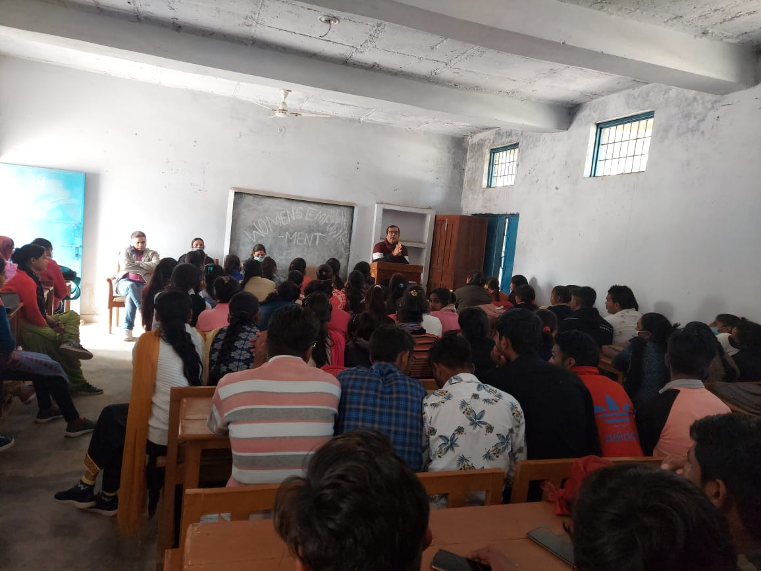
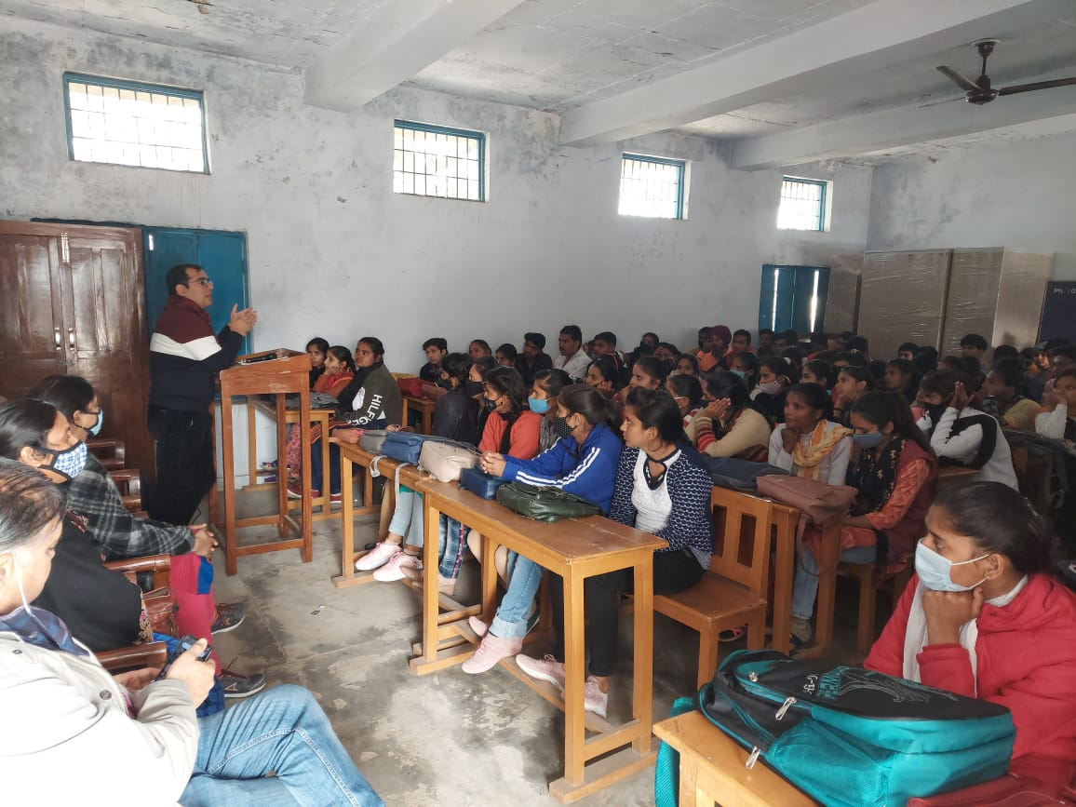
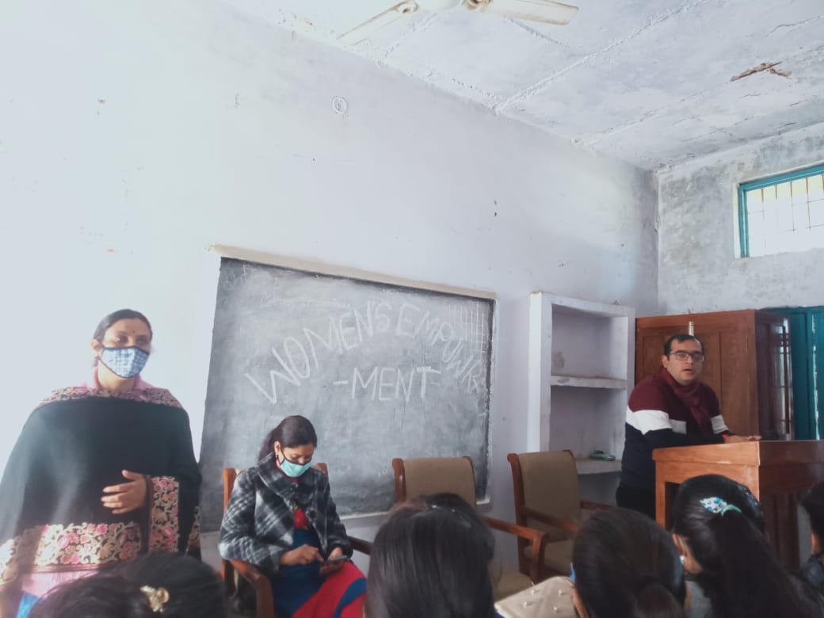
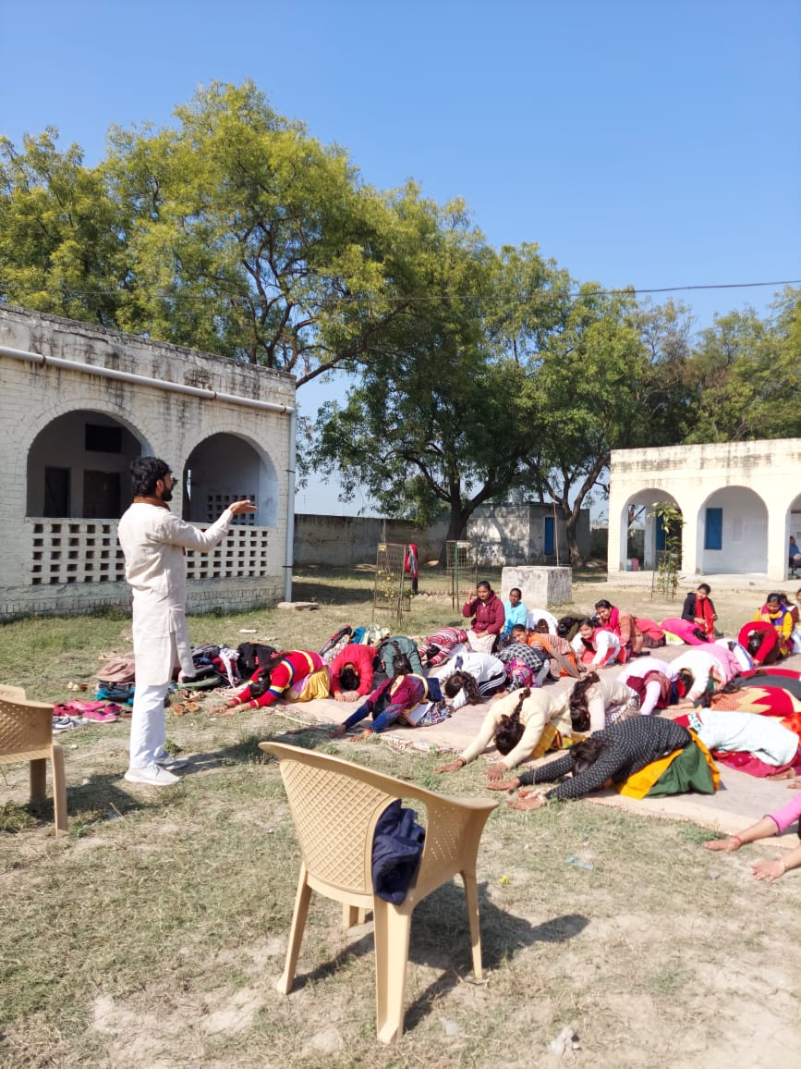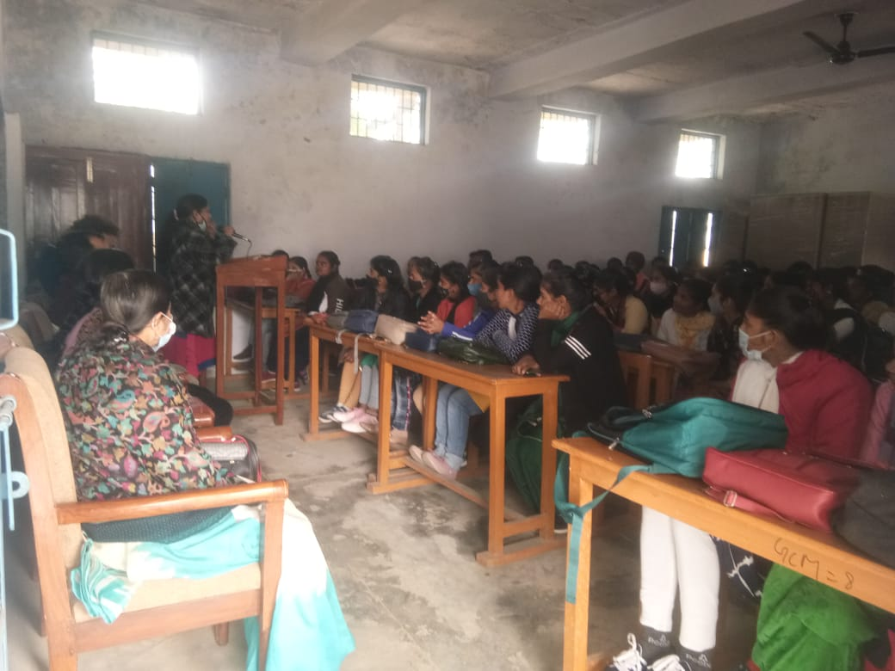

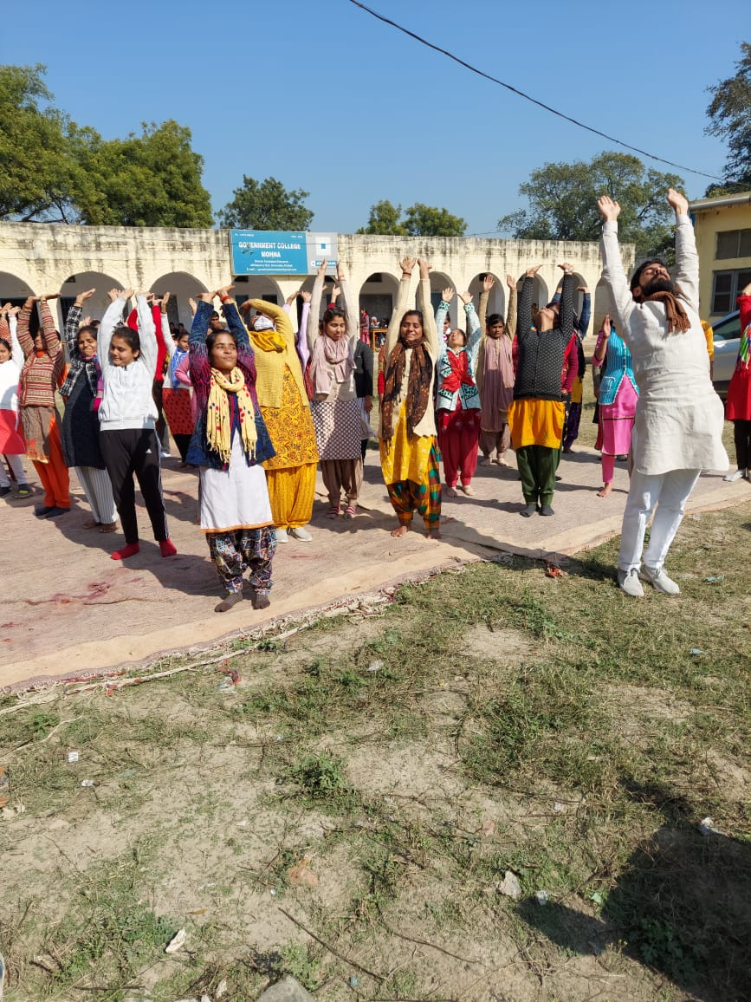
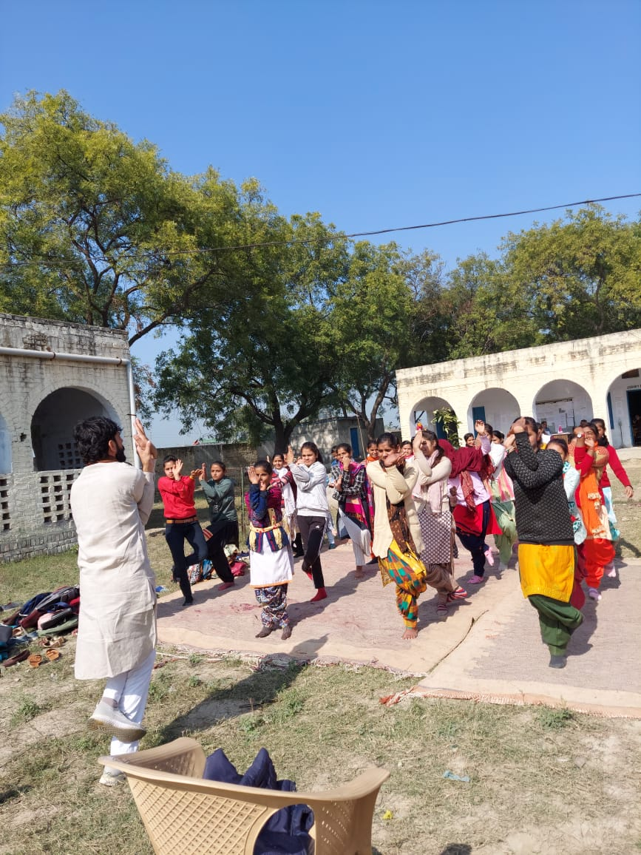
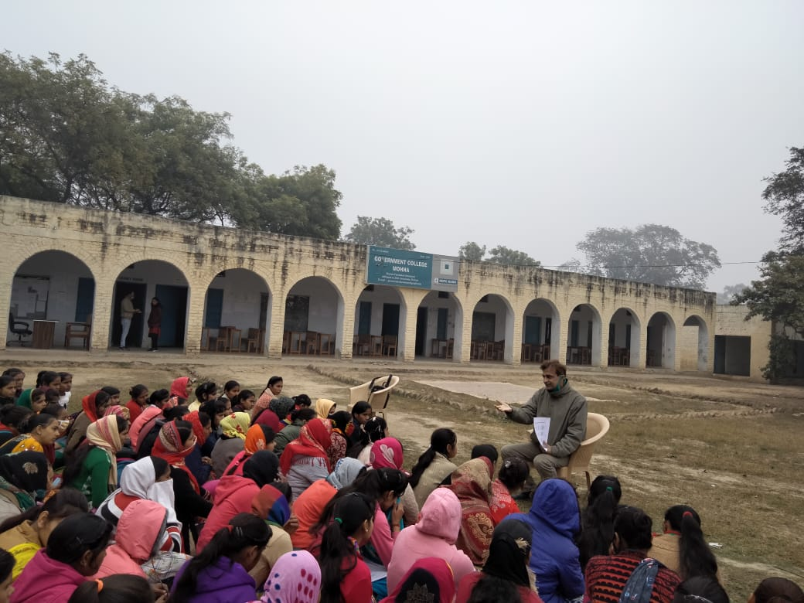
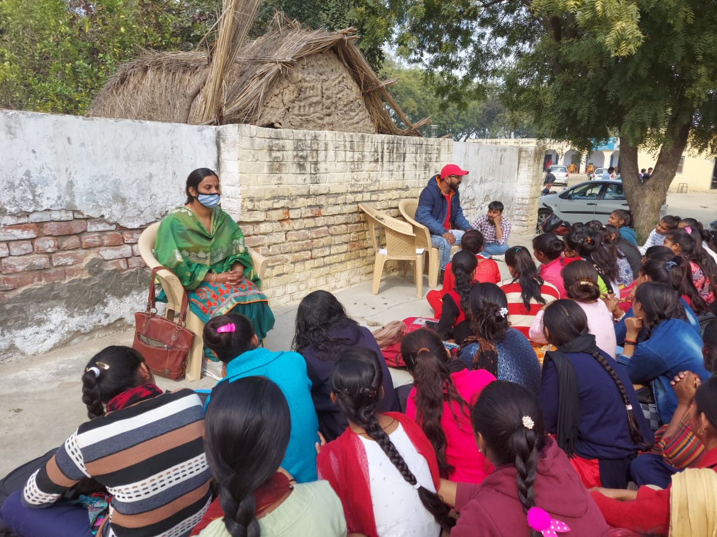

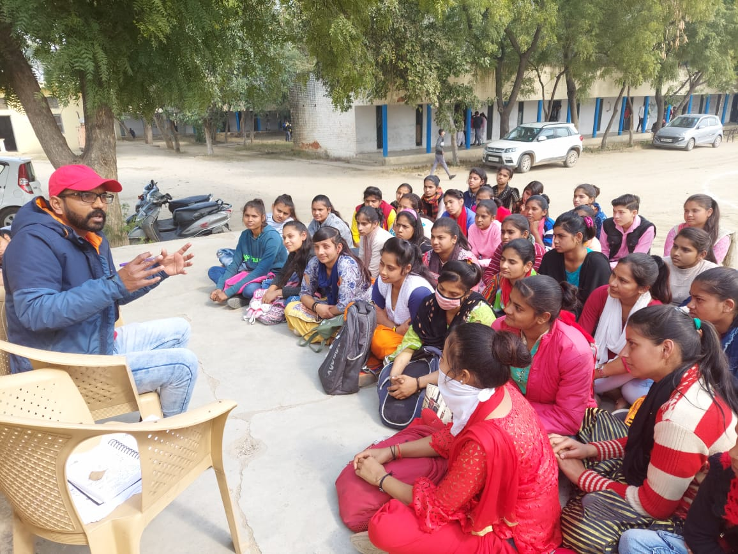
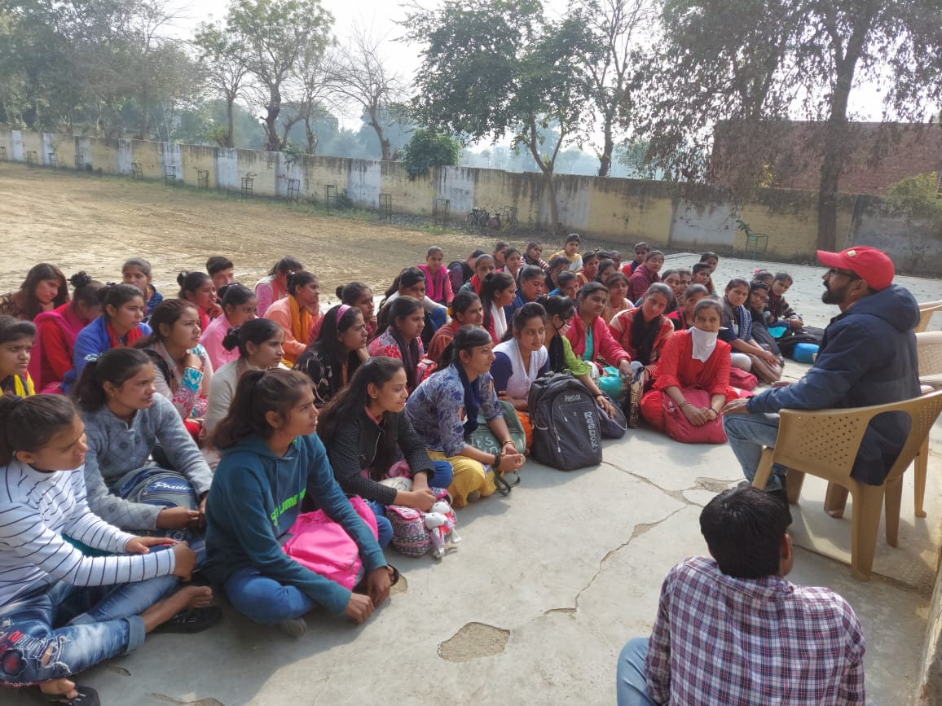
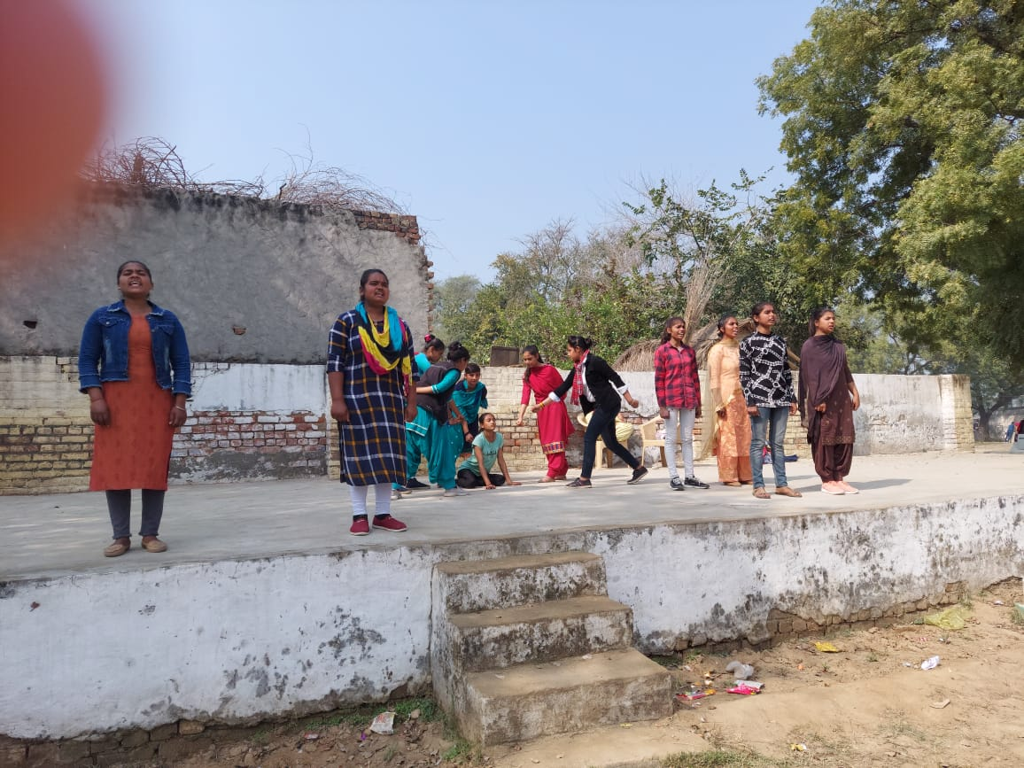
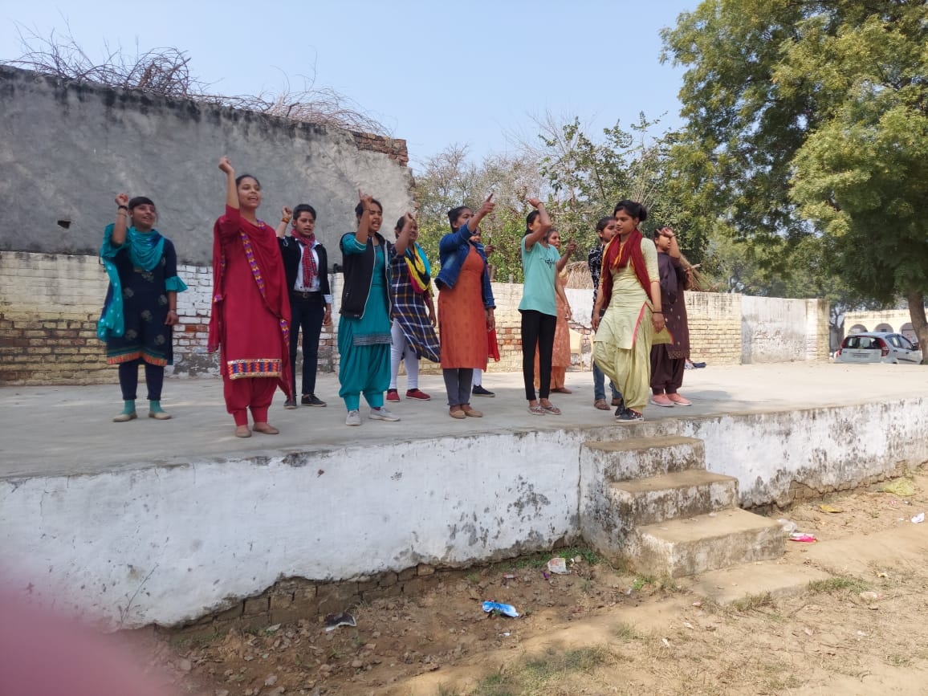
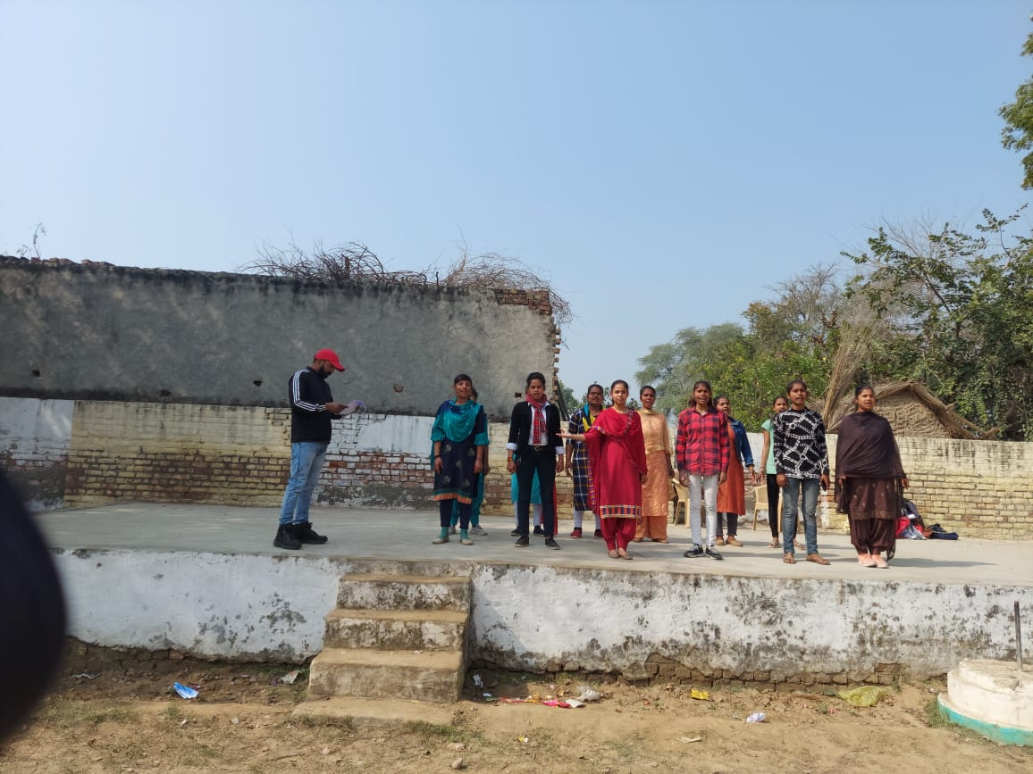

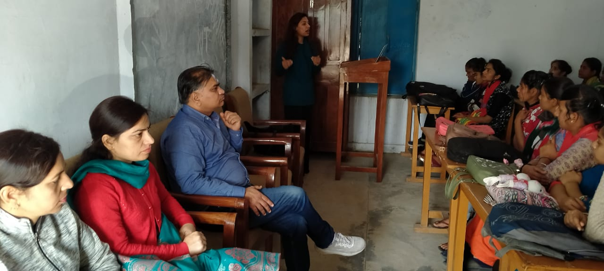
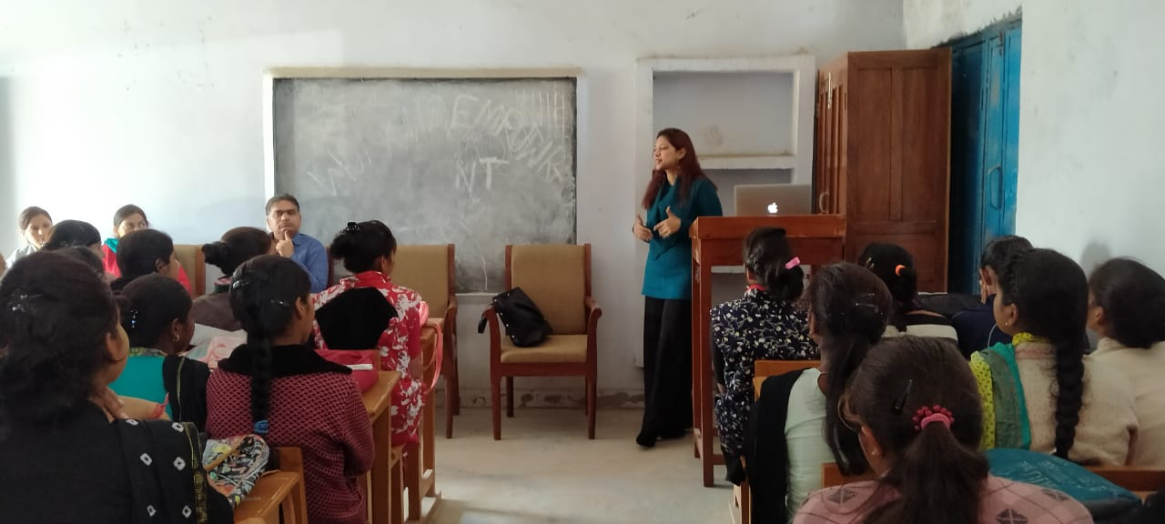
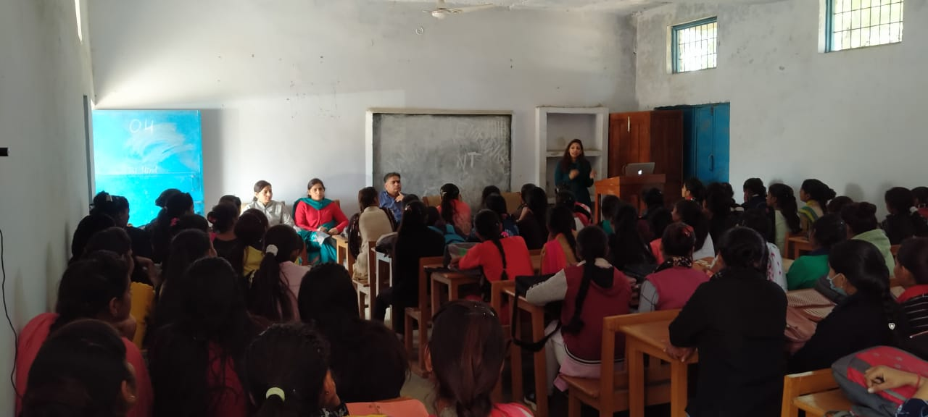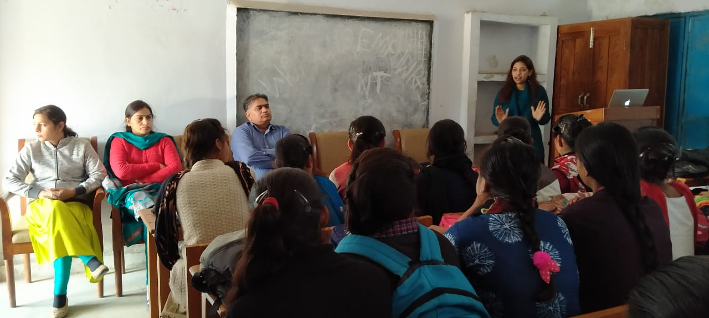

Neelam Chaudhary
In charge Women Cell

