NCC Report

The activities done by NCC cadets Senior Wing Government College, Mohna during session 2020-21 details is as per given below: -
- A conference for CTO/ANO was also called by CO 4th Haryana Girls Battalion Nuh on 07.01.2021 regarding different activities to be done under NCC.
- A three-day camp organized by G.G.S.D College, Palwal & 4 Har (Girls) Bn NCC, Nuh from 28.01.2021 to 30.01.2021.The major activities include Parade, Drill & Weapon Training for the cadets. On the last day of the camp a cultural was also organized in which cadets from our college also participated. The First, Second & Third position was won by Cdt. Pooja in dancing, Cdt. Sonam in slogan writing & Cdt. Sonia in singing consecutively.
- A one-day camp on Map reading was also organized by Commanding Officer, 4th Haryana Girls Battalion Nuh on 10.02.2021 at Hill view Point Nuh.
- More over Cadets also took social services like helping the staff on helpdesk at Government Hospital, Mohna for a week in January 2021. In February 2021 cadets prepared & maintained the playground of College.
- All the cadets gained lots of confidence, knowledge & were proud to be a part of the institution.
- Throughout the year PI staff from 4th Haryana Girls Bn Nuh visited & held both theory & practical classes.
- The first batch from our College’s NCC Senior Wing have completed one year & cadets will get “B” Certificate after the Examination to be held in March,2021.
- The enrolment of next batch of students interested in NCC is under process for session 2021-22.

THREE DAYS CAMP IN PALWAL

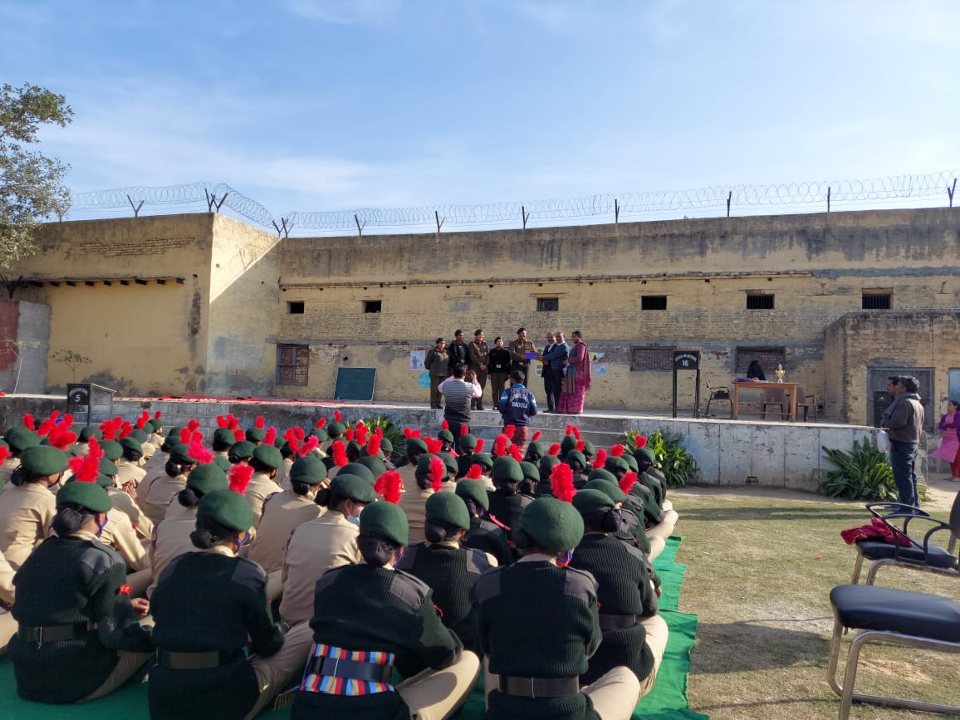
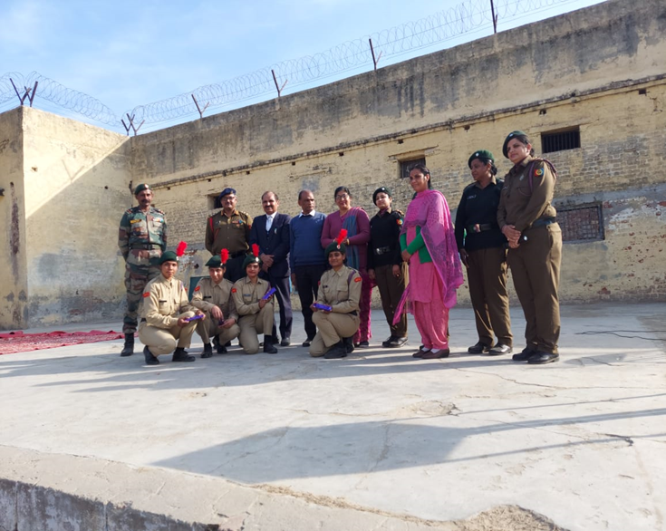

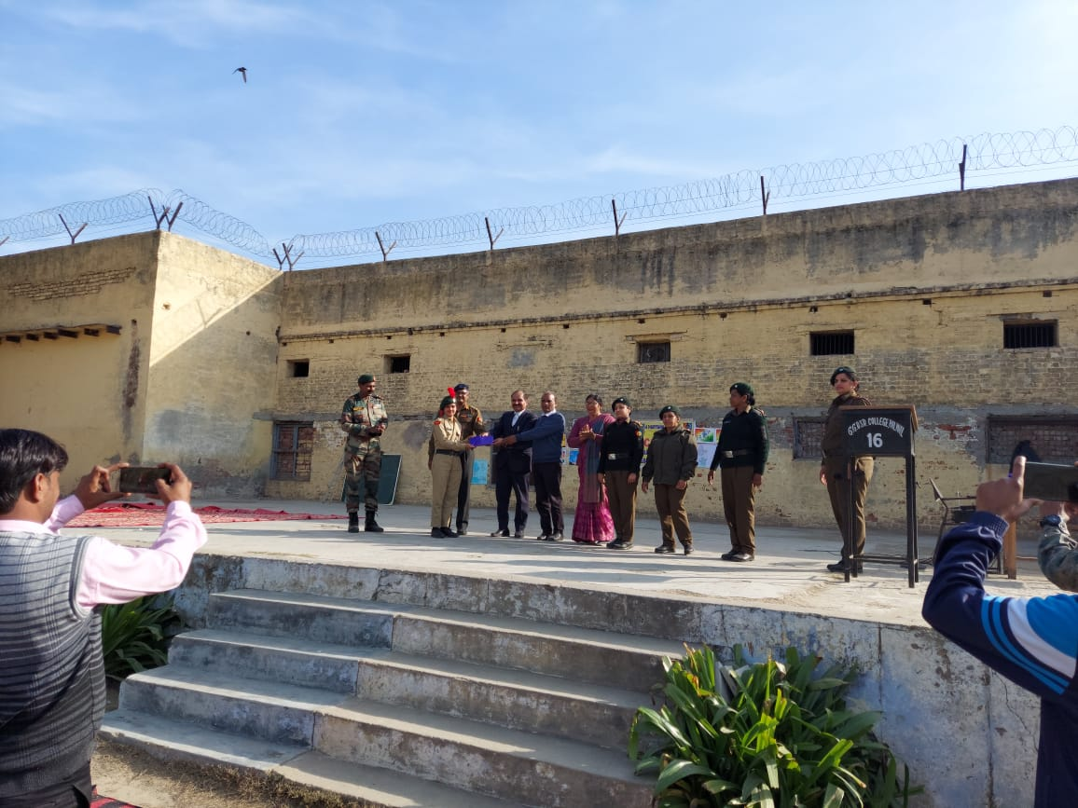
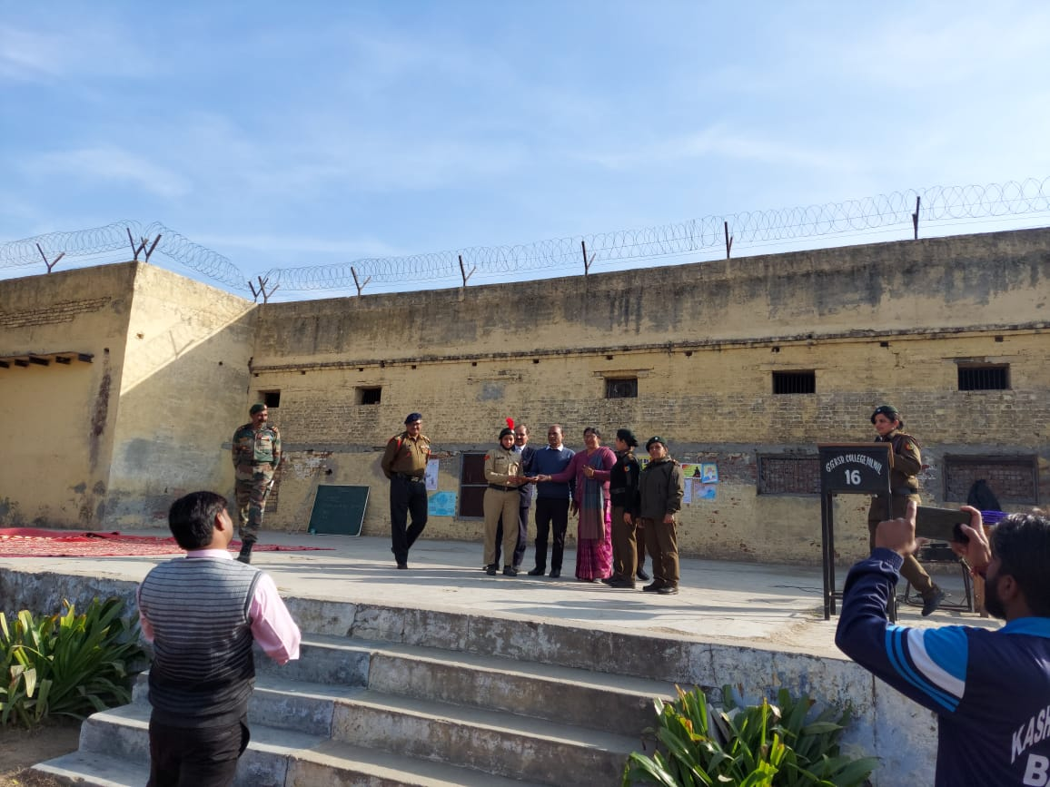
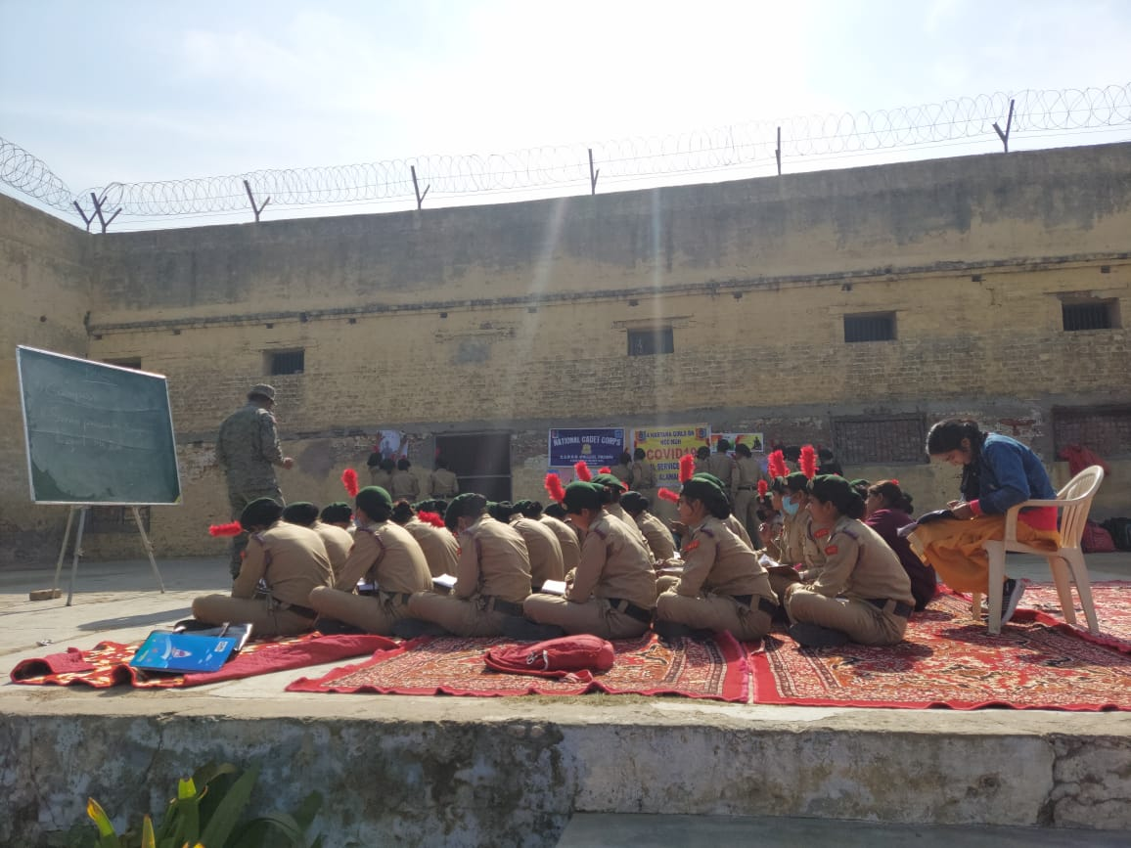
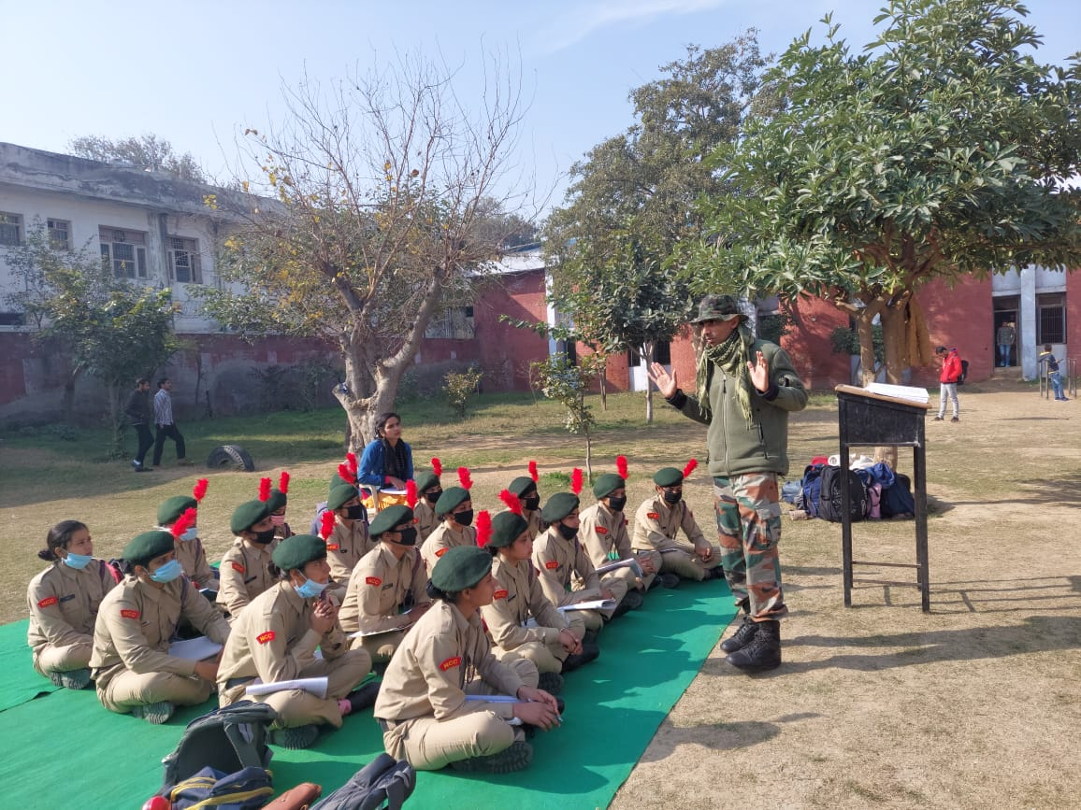
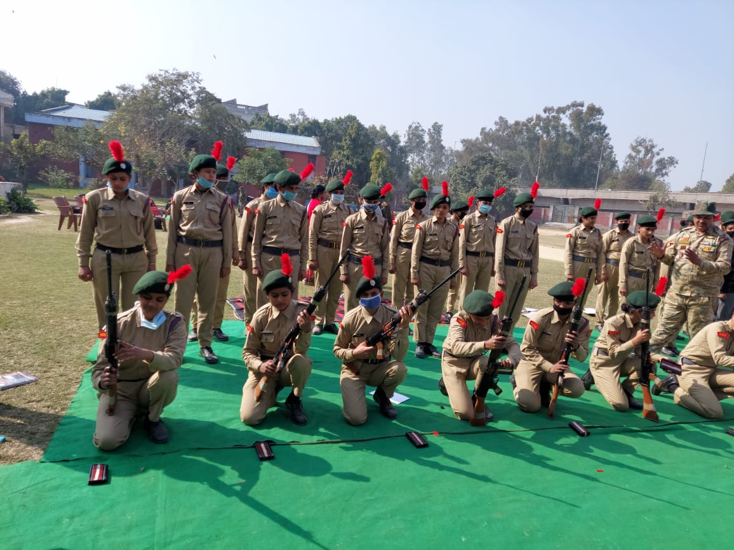
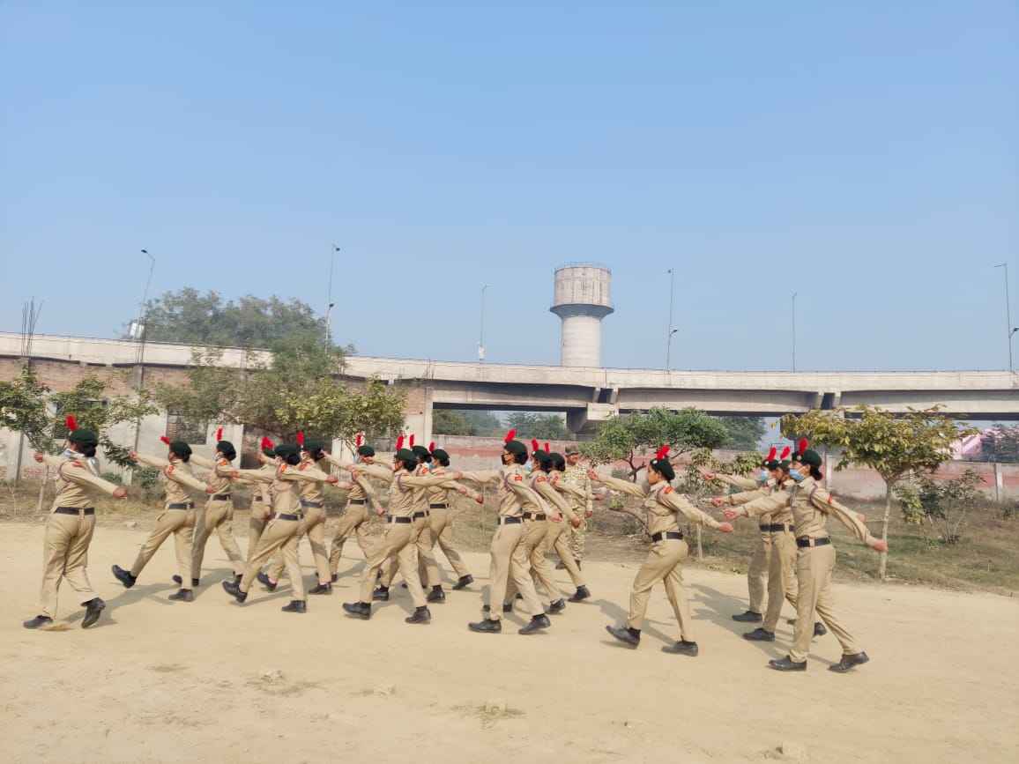

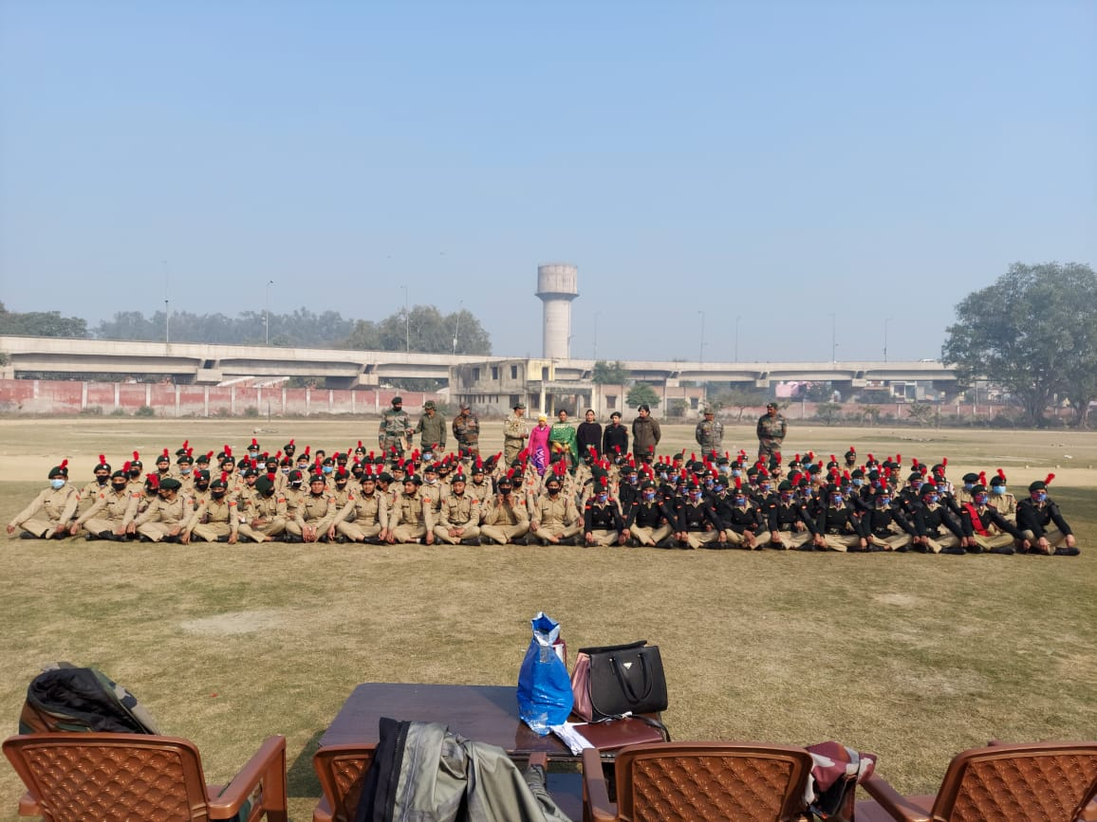
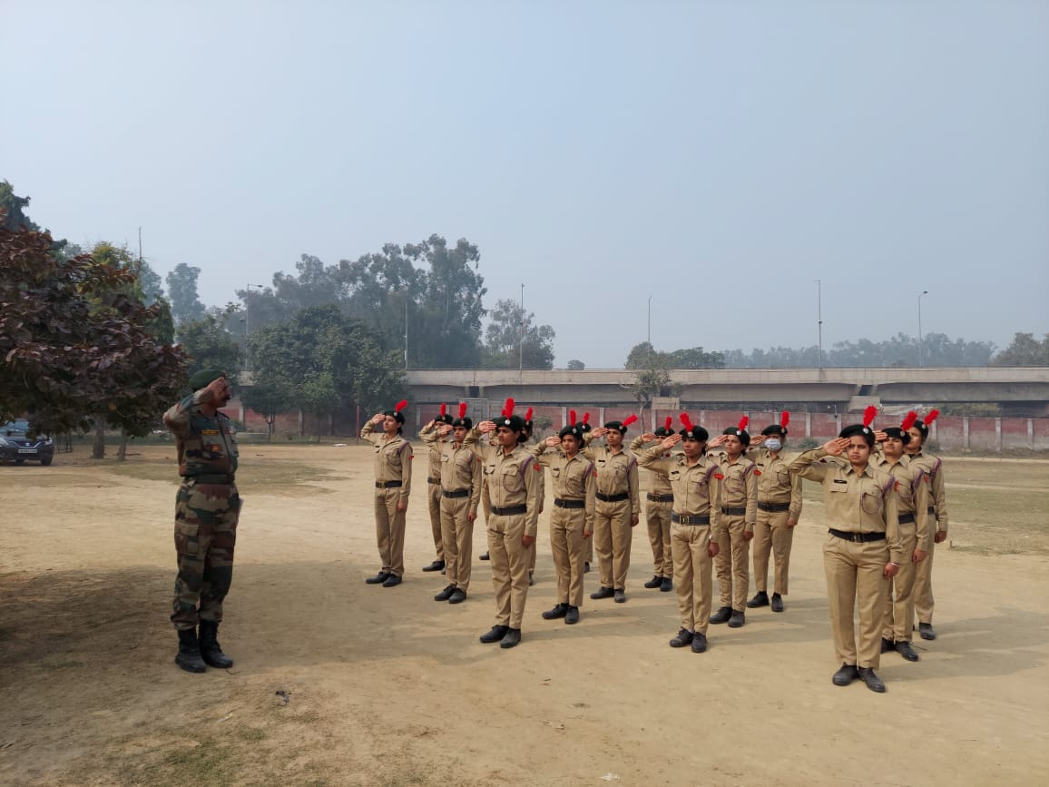
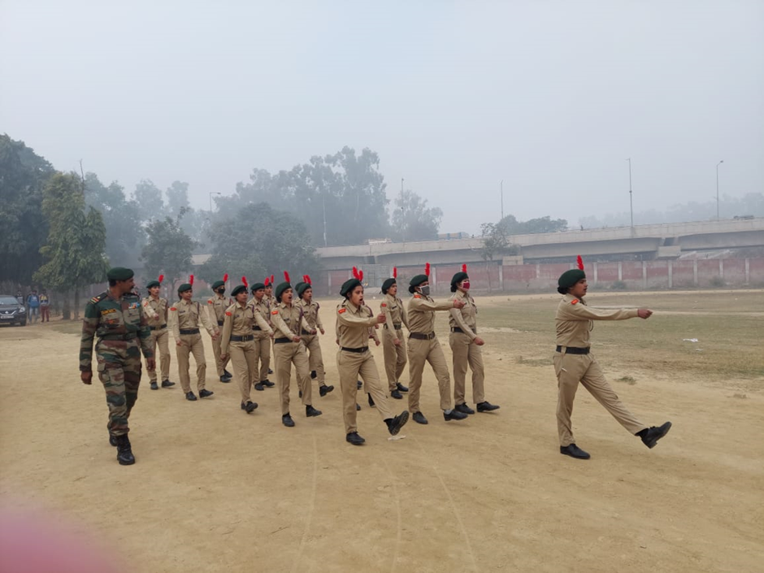

MAP Reading Hill Point View, Nuh

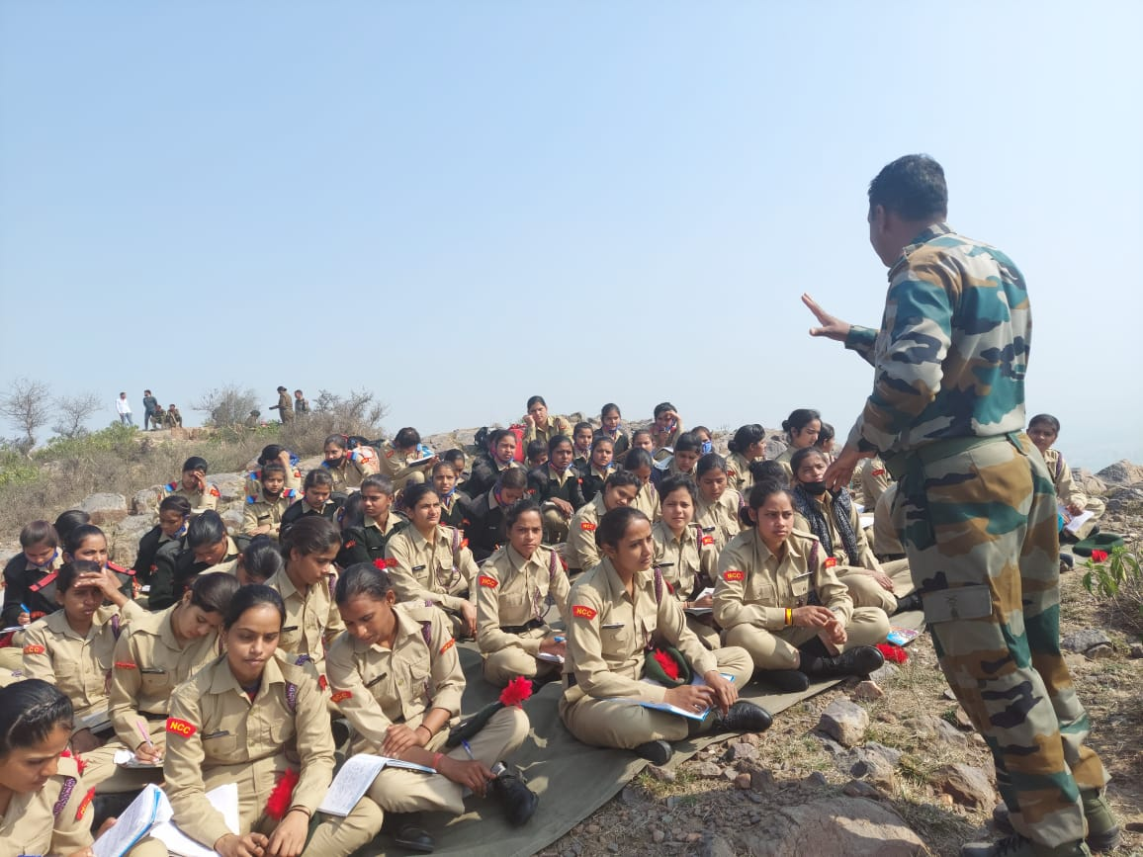

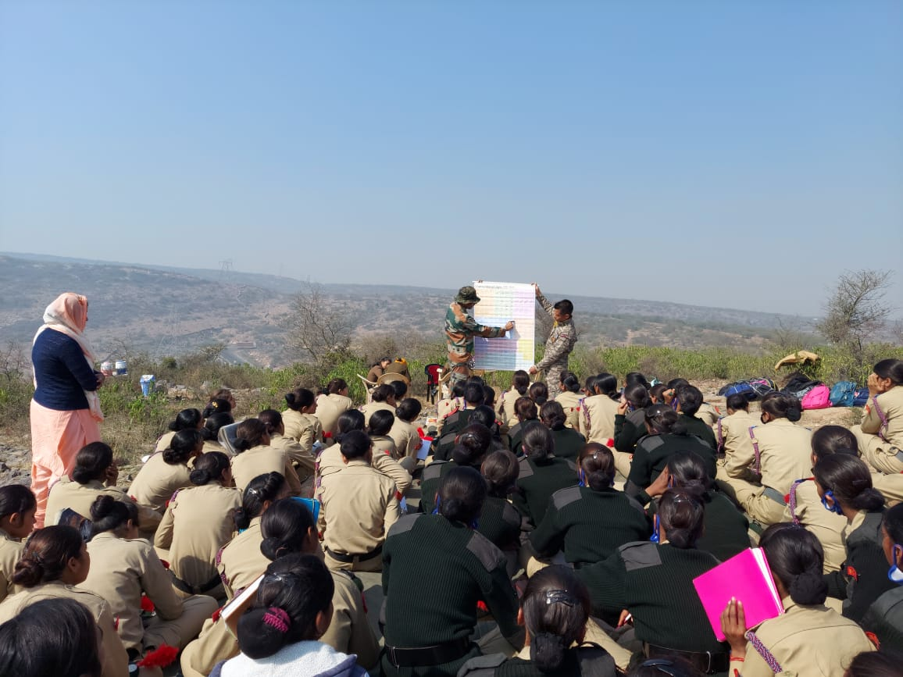
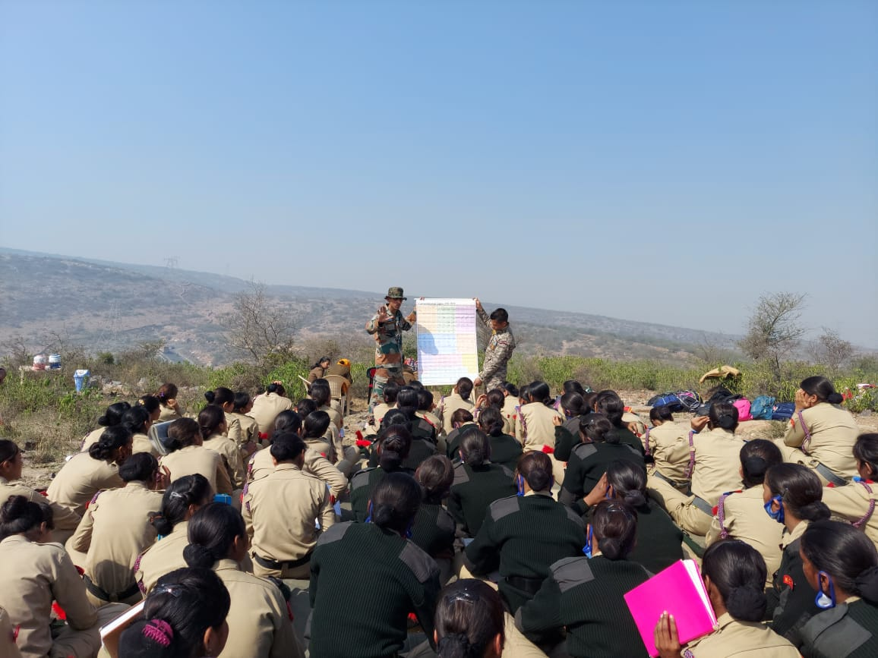

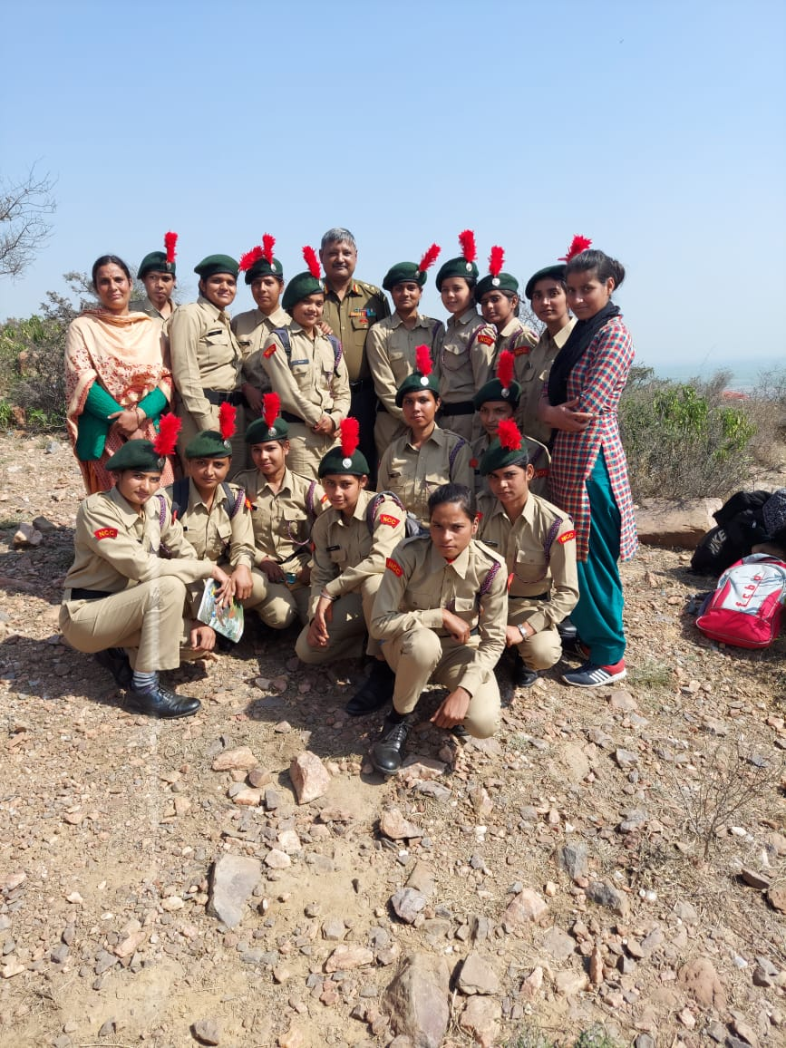

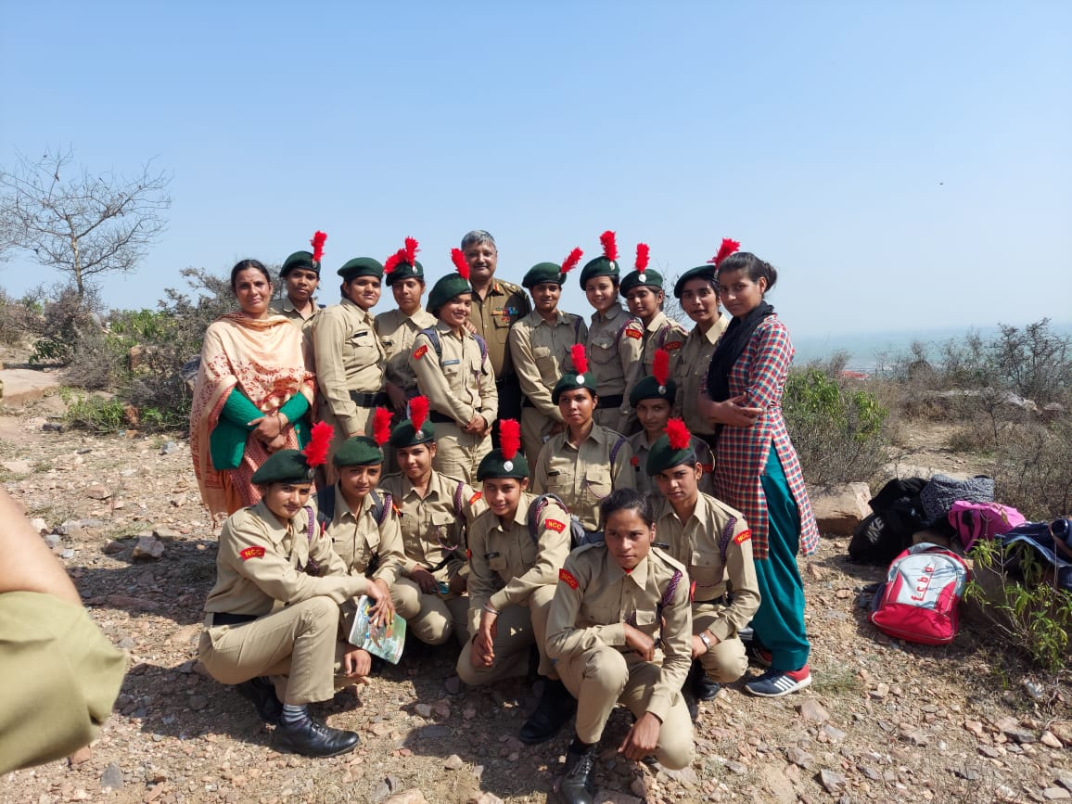

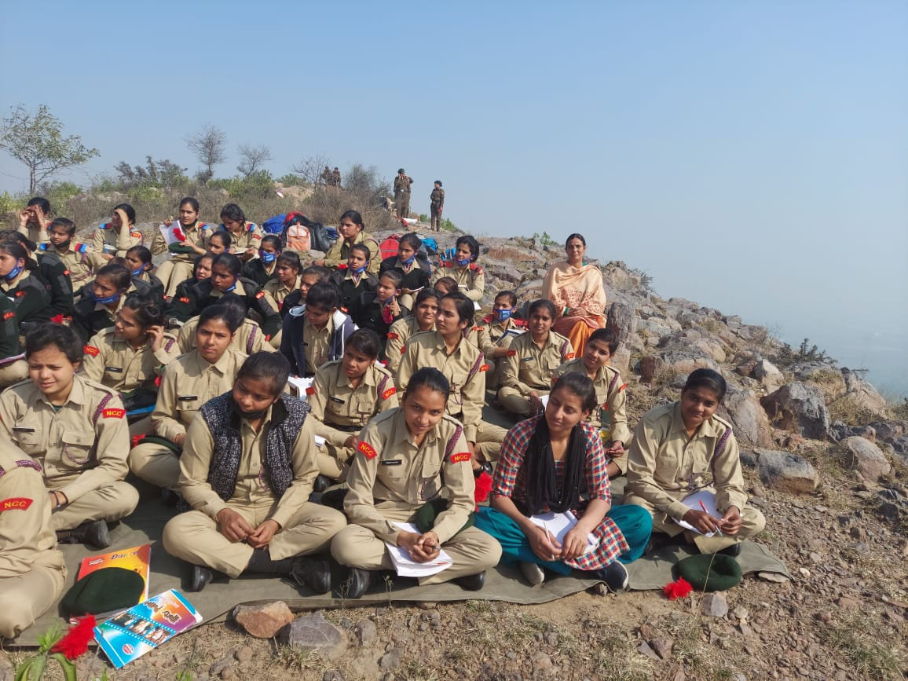
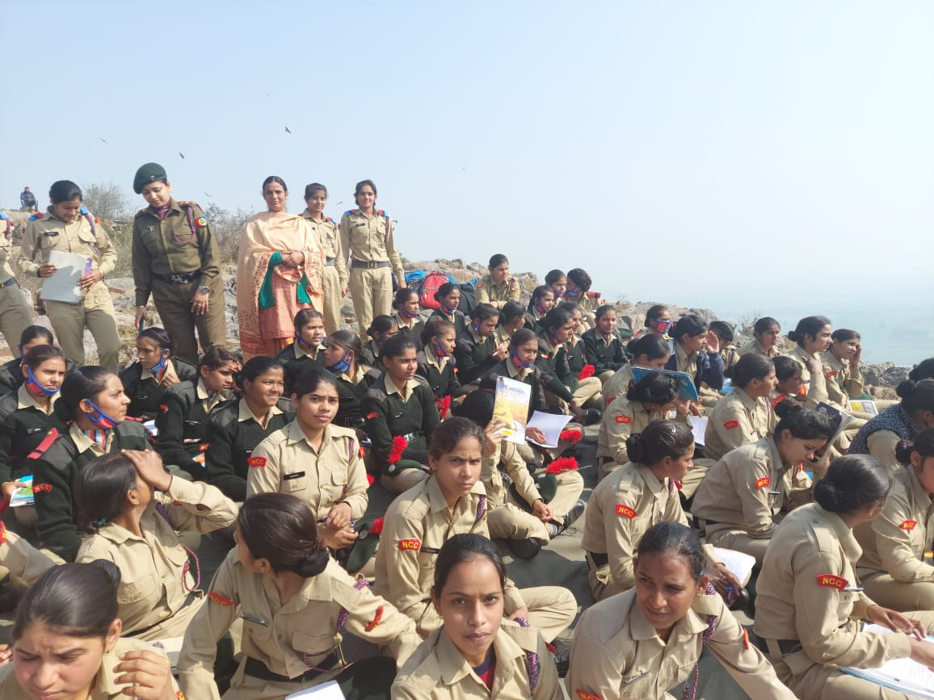

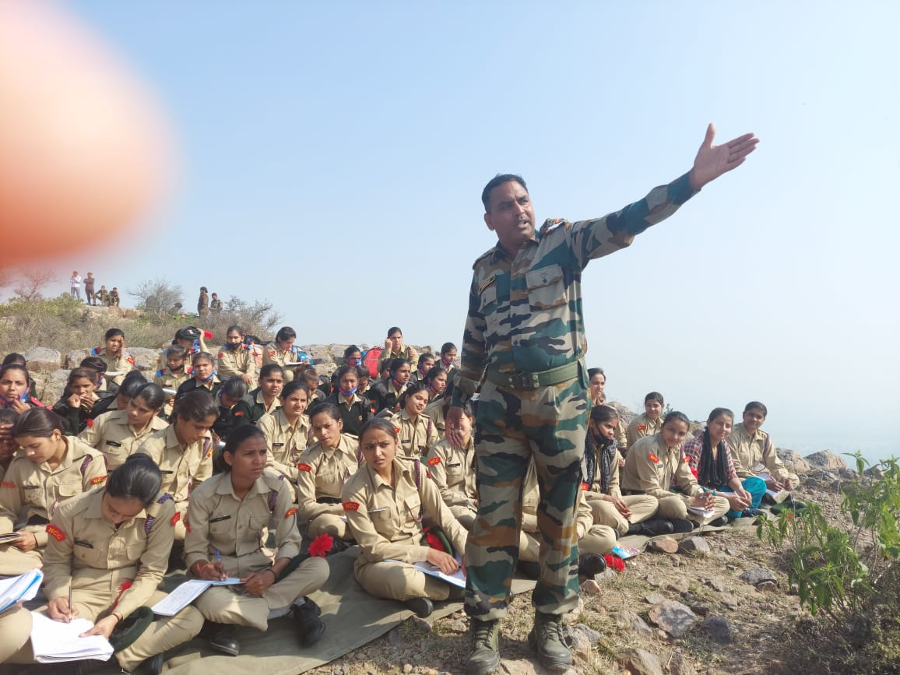

Discussion with CMO & Cadets on Help Desk Government Hospital

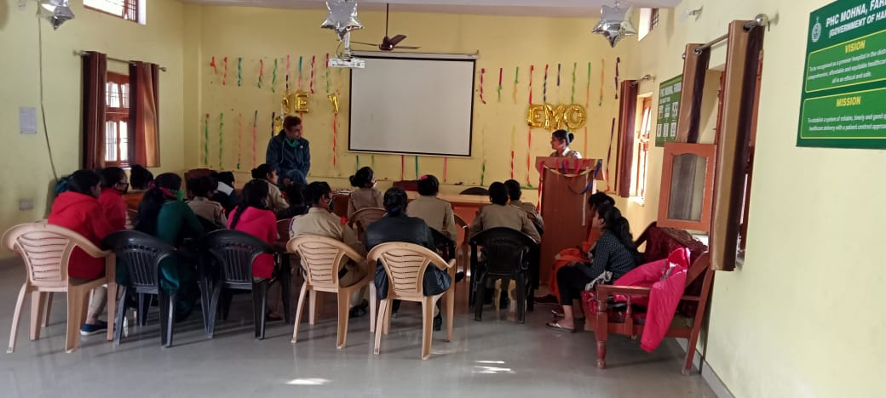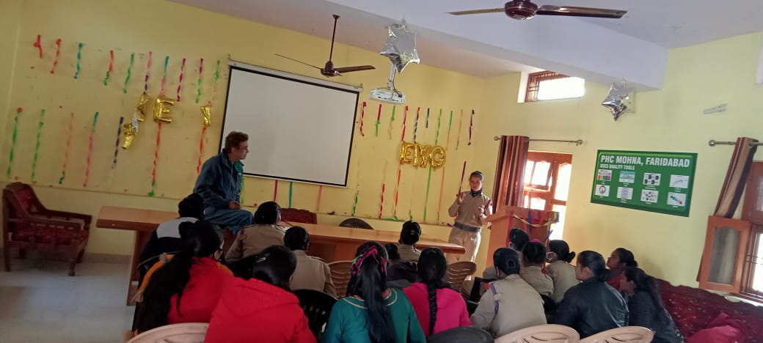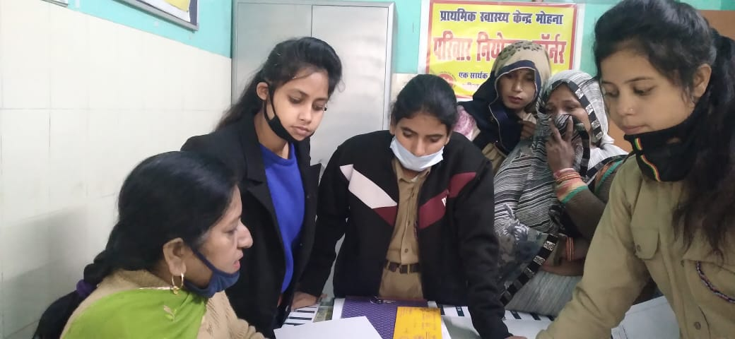
Preparing Play Ground
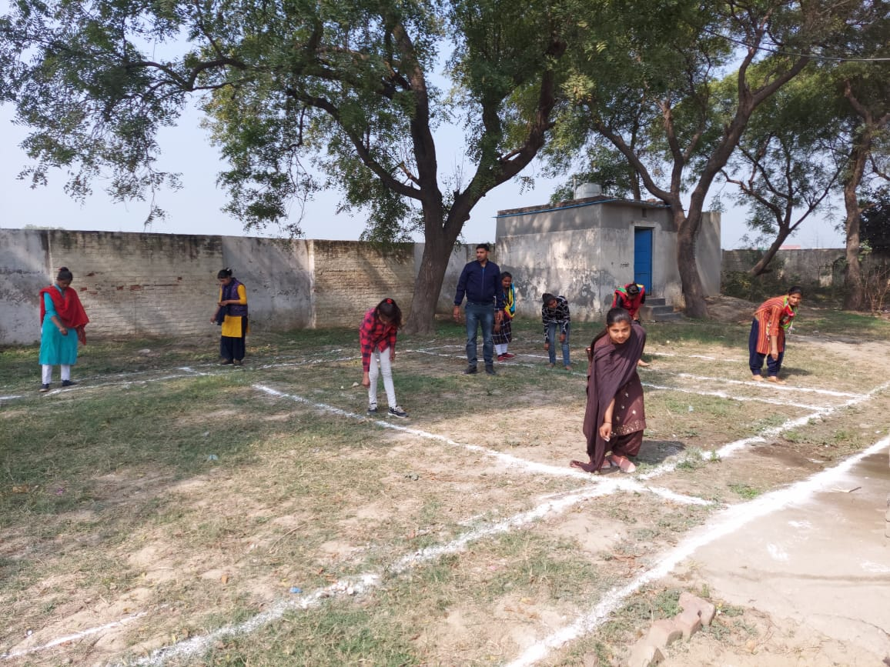

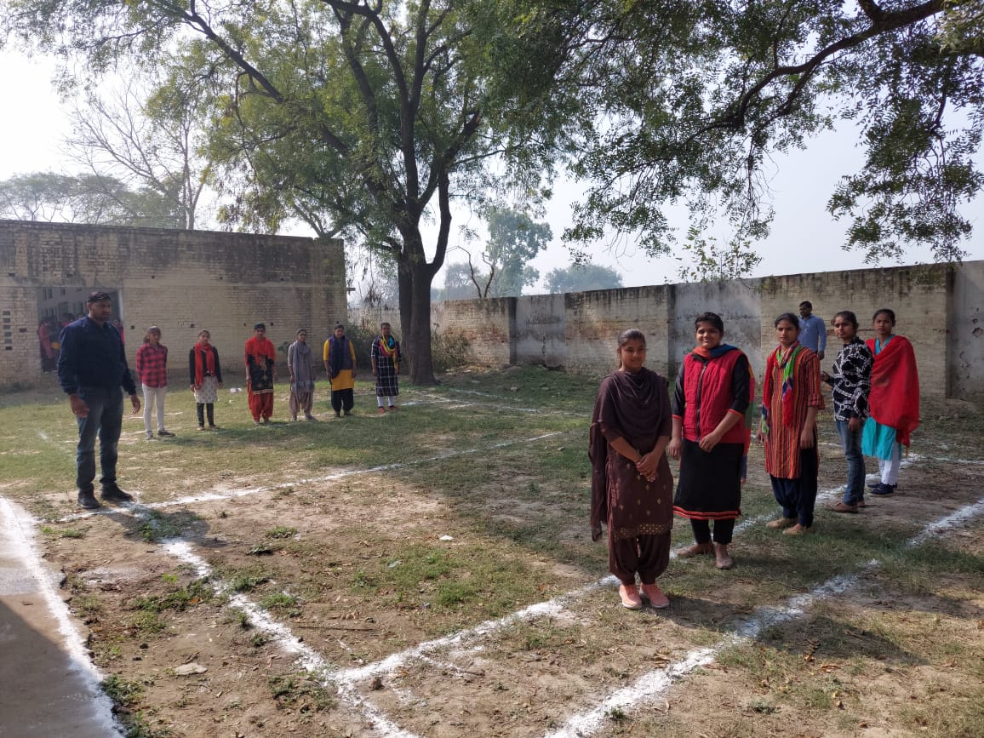

NCC (CTO)
Neelam Chaudhary

