GOVERNMENT COLLEGE MOHNA, FARIDABAD
REPORT OF NCC ACTIVITIES
(SESSION 2021-22)

The activities done by NCC cadets (Senior Wing) of Government College Mohna, during session 2021-22 are given below: -
DISCIPLINE DUTY DURING ADMISSION DAYS
NCC cadets of Government College Mohna, performed the discipline duty during admission days for the session 2021-22. The task was to maintain discipline and help the new comers during the month long admission process. Around 18 cadets were appointed to maintain discipline in the college premises
ANNUAL ATHLETIC MEET 2021-22 (03/12/2021)
On the occasion of annual athletic meet, NCC cadets actively participated in the discipline maintenance of the function. All cadets were filled with great enthusiasm. They performed the duties, assigned to them, very well.
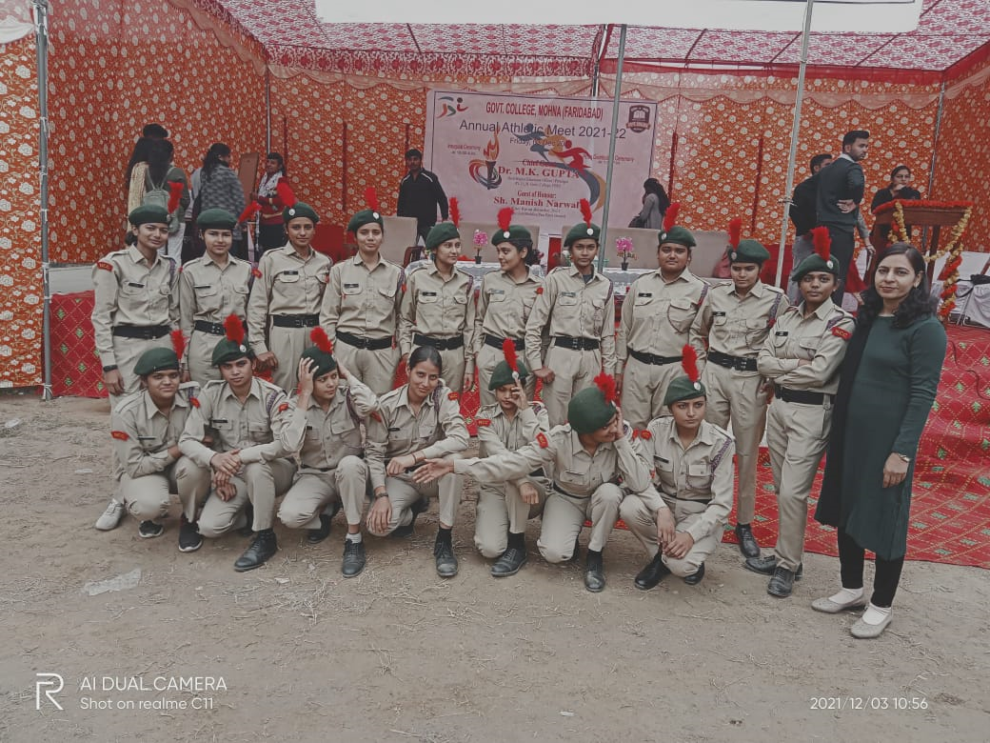
COMBINED ANNUAL TRAINING CAMP (13-19 DECEMBER, 2021)
In Government College Mohna, an Annual Seven Days’ Camp was organized from 13 December to 19 December, 2021. In this camp, total thirty cadets participated out of which 15 was for C certificate and rest 15 was for B certificate. During the camp special training and lectures were given to the cadets. On 13 December, PI staff from 4 Haryana Girls Battalion NCC, Nuh were Subedar Arif Ali, Nayak Rajesh Kumar and Sishal Sanjay. Rest of the days there were only two PI staff (Subedar Arif Ali, Nayak Rajesh Kumar).
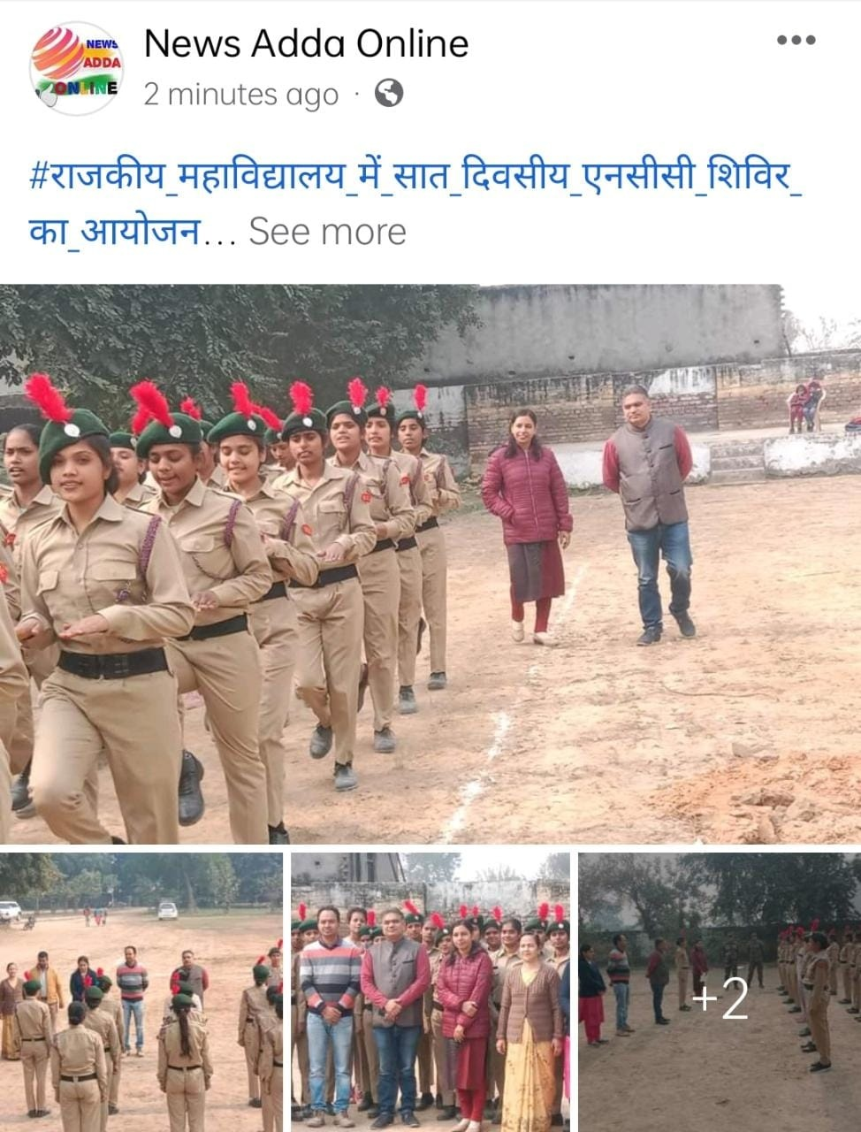
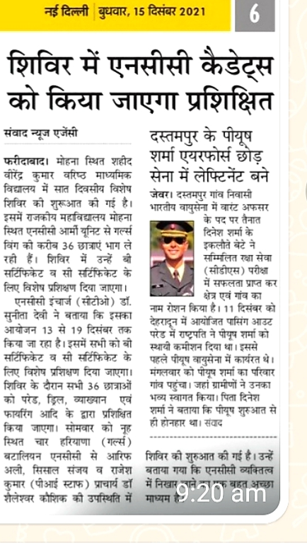
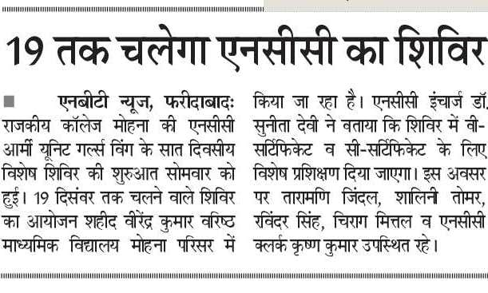
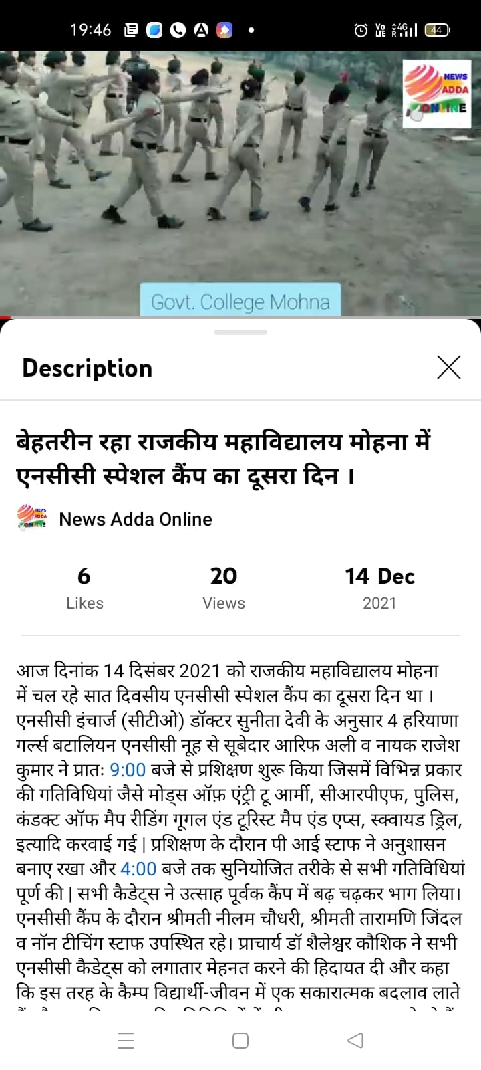

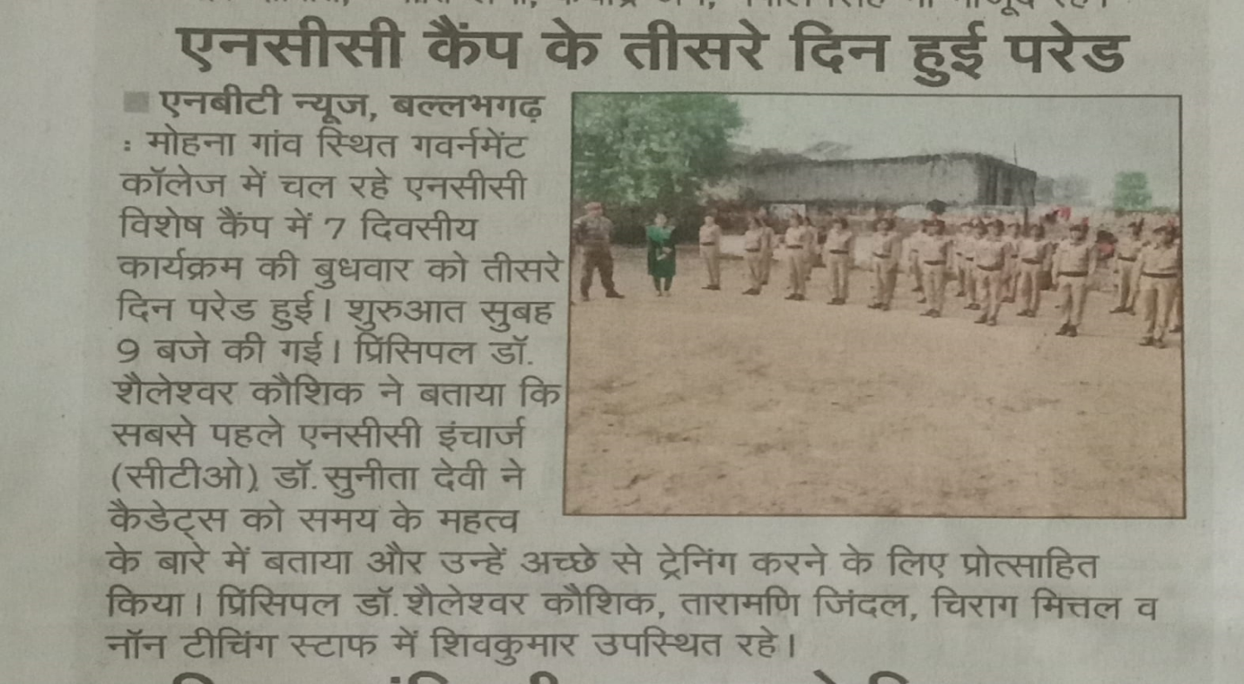
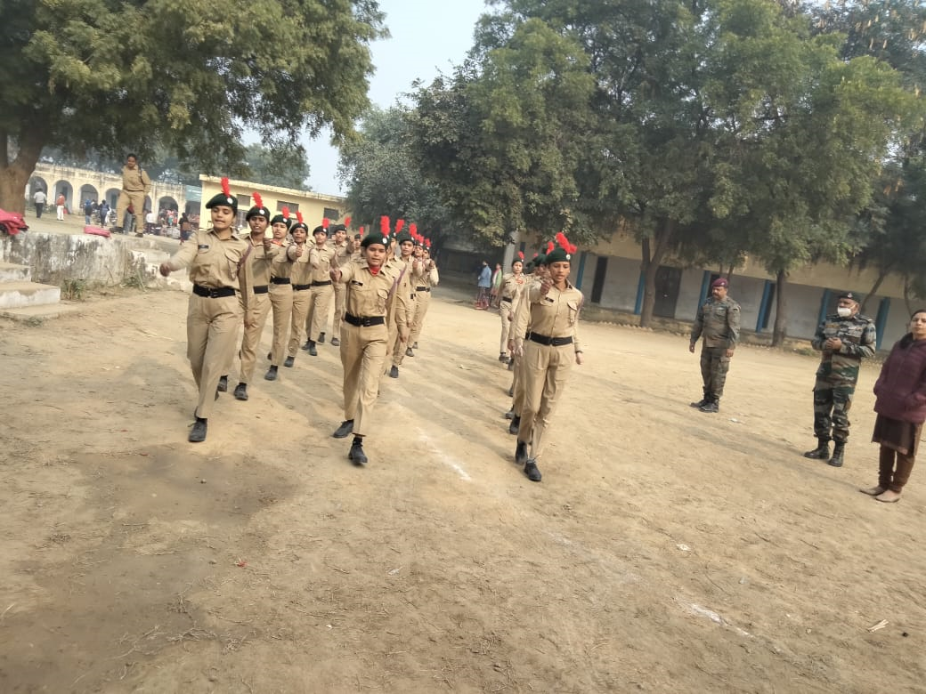

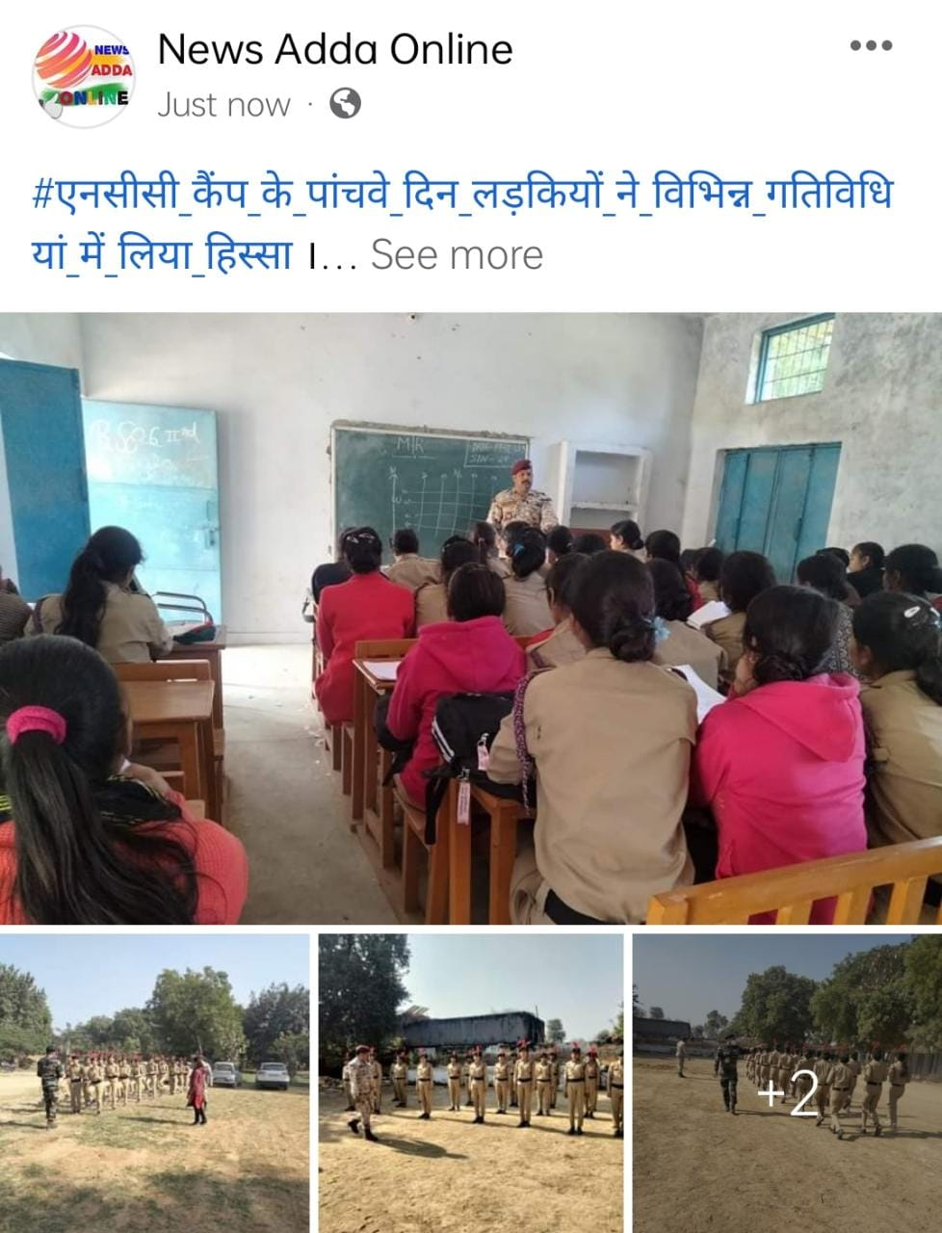
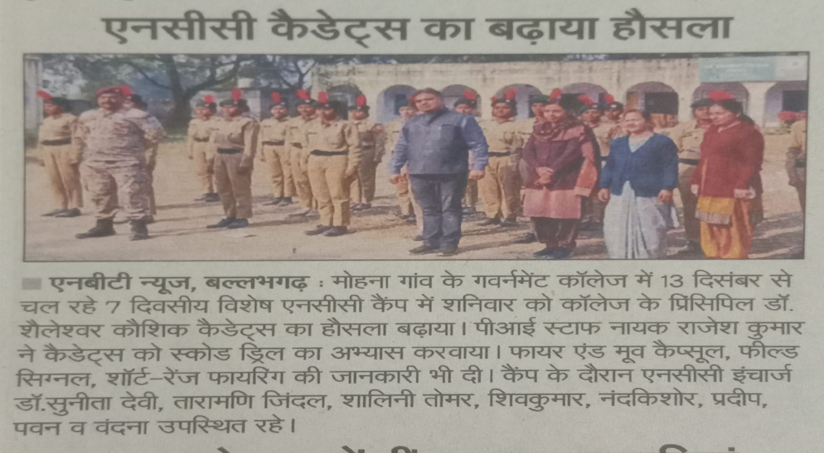

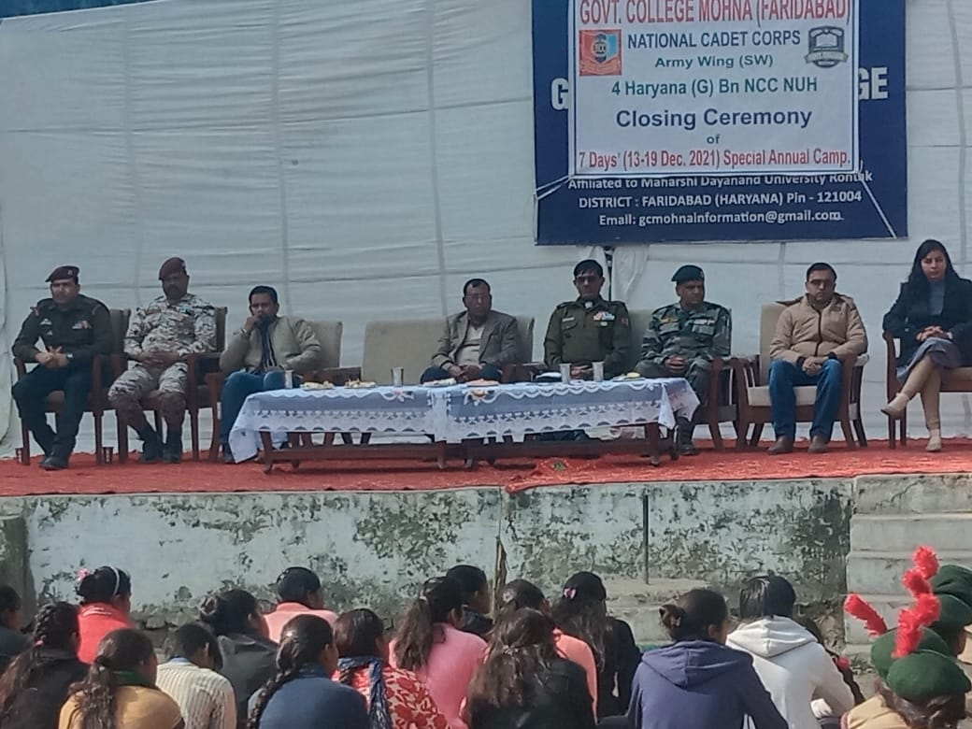
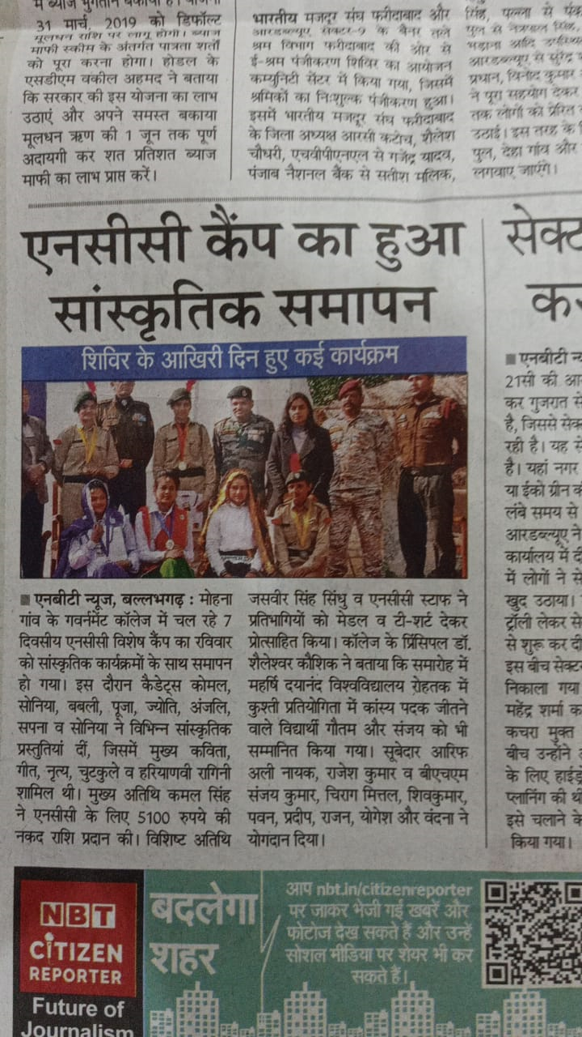

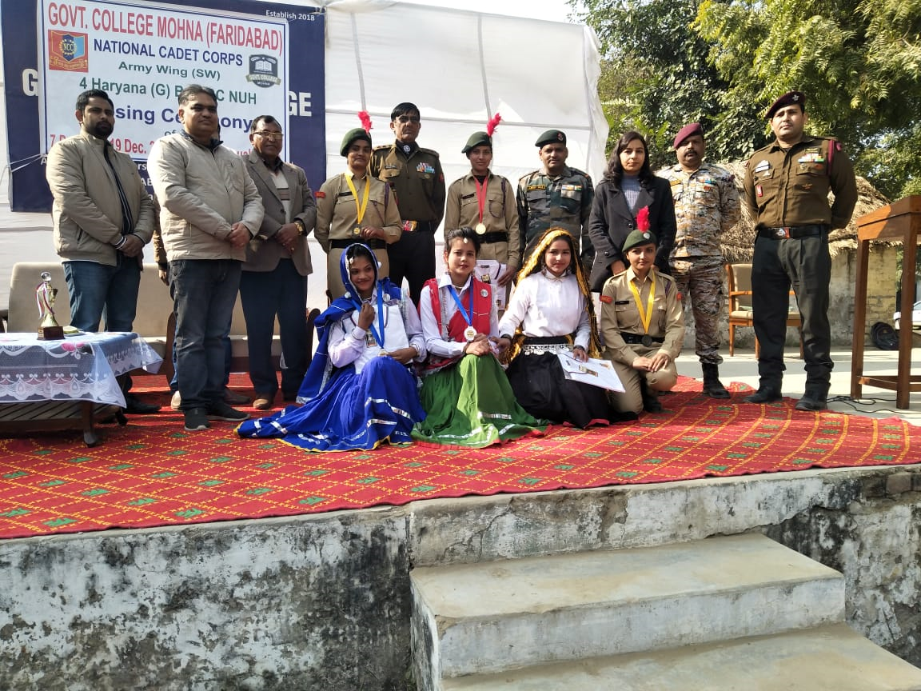
TRAINING CAMP ON MAP READING
A one-day camp on Map reading was organized by Commanding Officer, 4th Haryana Girls Battalion, Nuh on 10.02.2022 at Hill View Point, Tauru Road, Nuh. All cadets of Government College Mohna, attended the camp.
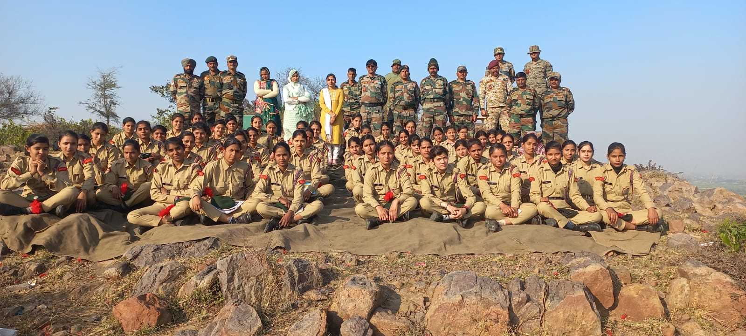
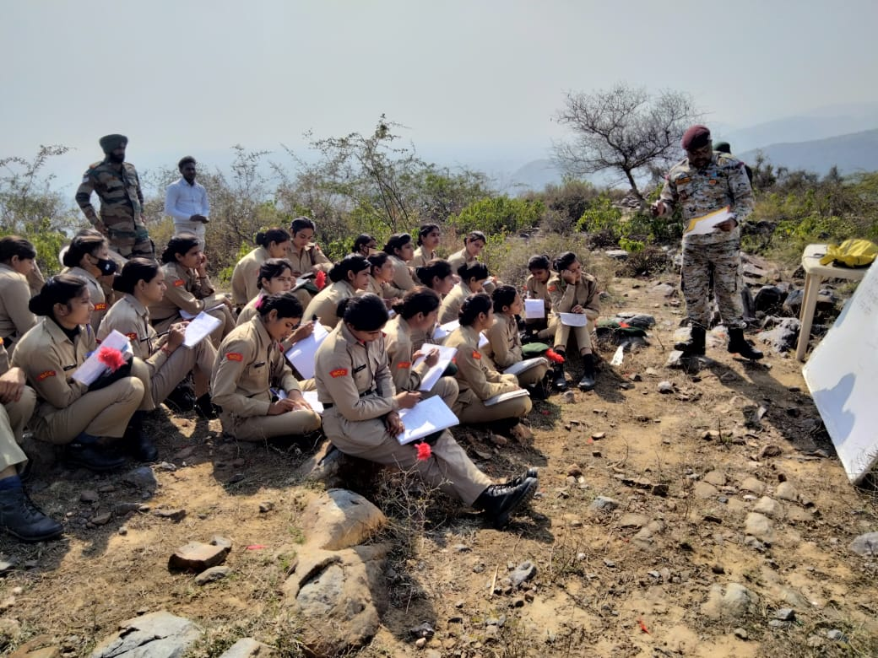
THEORY AND PRACTICAL CLASSES
Throughout the year PI staff from 4th Haryana Girls Battalion NCC, Nuh visited & held both theory & practical classes.
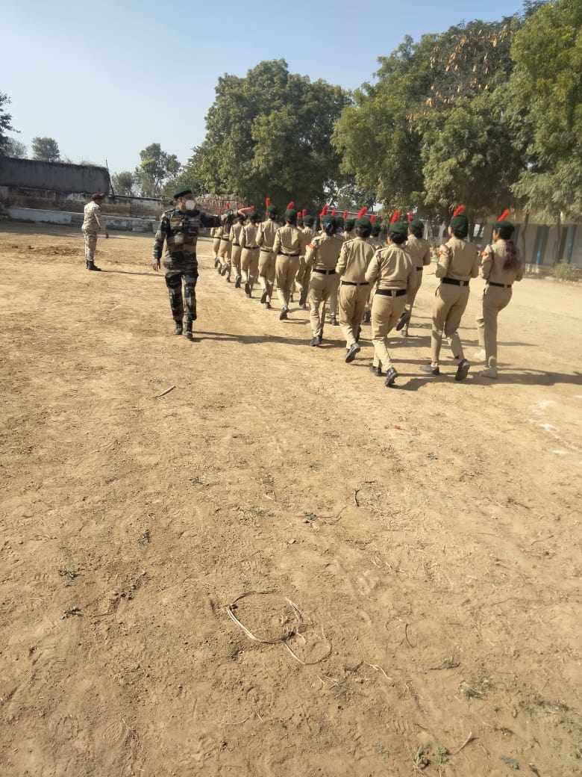
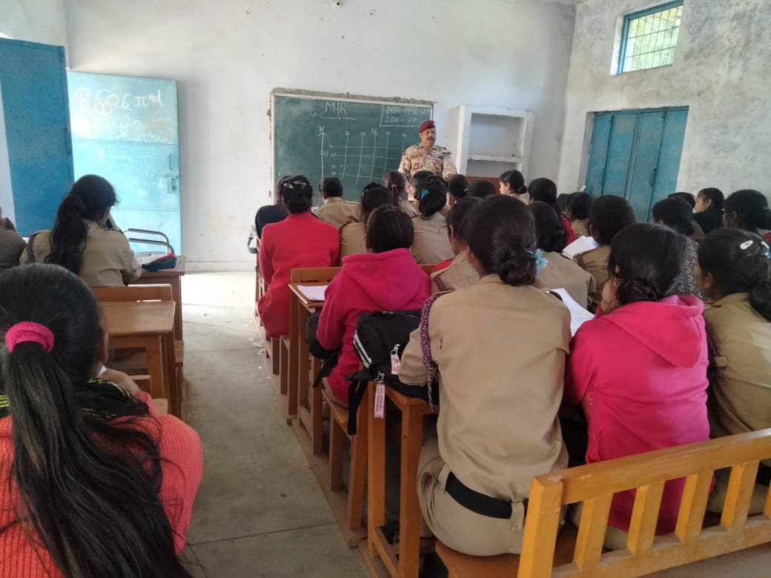
RESULT OF ‘B’ AND ‘C’ CERTIFICATE EXAM
During the session 2021-22 all appeared cadets qualified their respective exams. Performance of the cadets is as follows:
Examination | Cadets Appeared | Cadets Passed
‘B’ certificate | 15 | 15
‘C’ certificate | 16 | 16

TRAINING CAMP
Six cadets of Government college Mohna are selected for attending the EK BHARAT SHRESTH BHARAT CAMP (EBSB-1).
NAME OF THE EVENT | DATE | LOCATION | NO.OFCADETS PARTICIPATED
EBSB-1 | June 4-15, 2022 | MALOUT,PUNJAB | 4
EBSB-1 | June 21-July 2, 2022 | KODERMA | 2
CATC 174 | June 11-June 20, 2022 | SSC Academy | 25

DR. SUNITA DEVI
NCC CTO

